Children’s voices on the impact of Covid-19

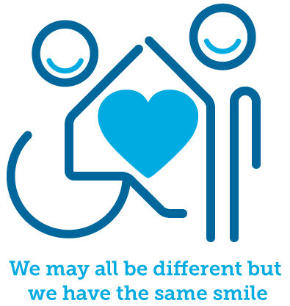

The Multi-school’s council

April 2022

Introduction

Meetings across Essex

During March 2022, we spoke with just under 300 young people across Essex, all with varying abilities, from different backgrounds and between the ages of 5 and 18. We asked the different groups we spoke to about the impact they felt covid-19 had had on themselves but also their peers.

The work took us to Colchester, Tendring (x2), Braintree, Chelmsford (x2), Basildon, Brentwood, Harlow, and Thurrock. The children would like this report to be shared with anyone working in health, education, or social care to help manage the return to some normality, while also considering the impact covid-19 is still having on many different individuals and families.

The report also reflects some of the feedback we have had from children over the past 24 months and the various changes children have had to deal with.
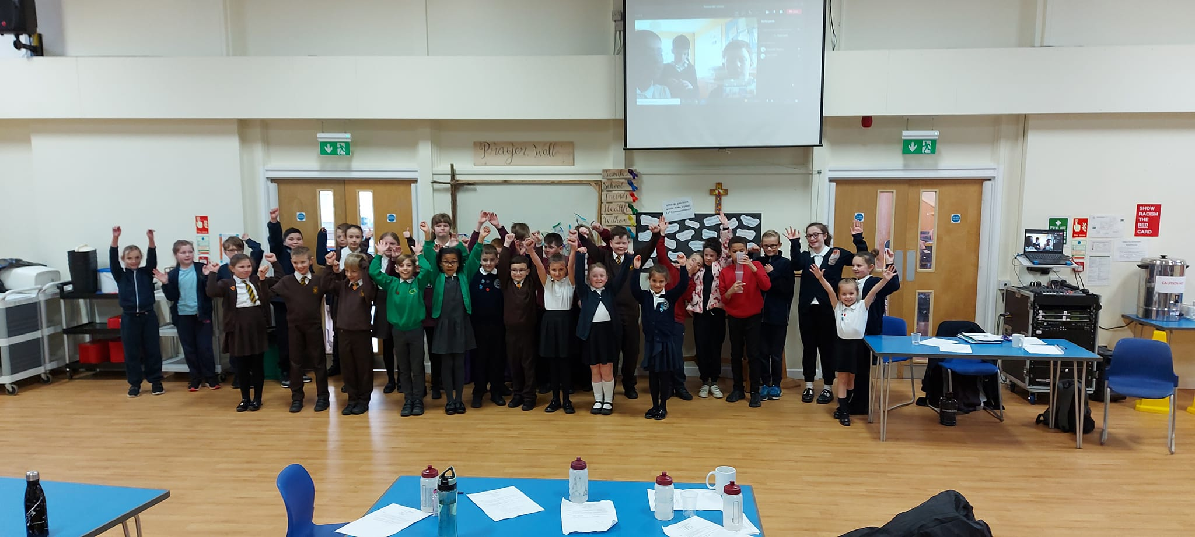

The mental health impacts

The biggest theme that came out of the meetings was the overall negative effect the pandemic had had on children’s mental health. We have broken down the key issues the children spoke about below;

Children not coming back to school
Due to an increase in feelings of anxiety/uncertainty children felt more of their friends were missing school or did not want to come back. Children suggested using technology creatively as a way of making sure their friends could still be involved and so it didn’t affect their mental health by being out of school. The Multi-school’s council will be speaking to children in the summer term on the issue of school attendance.

More staff needed
Children felt that more staff were needed in schools to ensure that they had enough people to talk to. In addition to more staff, the children would like to see more training for staff so that they can better support their needs. They would like schools to explore options for making sure more staff are trained.

Well-being hubs
Many children would like to see the introduction of well-being hubs within their communities. They feel this should be a direct response to the pandemic and offer a safe place for children to talk about their mental health.

Children with SEN
Our council has a strong focus on children with SEN and how we can challenge negative perceptions. The groups felt more understanding about children’s SEN needs was needed in relation to their mental health and how other groups supporting children’s mental health needed more training in this area.

Links to support our mental health
Children told us they didn’t always want to go through adults to find the right mental health support and wanted information on

links themselves. They wanted schools to consider how they share mental health support links with their children and how children could become more aware of what’s out there.

Loneliness
Often loneliness is something that is discussed in relation to older people and the impact this can have on their mental health. The children we spoke to said they felt this was a growing issue for the younger generation. They felt this was a direct impact of covid-19 and the lack of opportunities out there for children to interact.

Mental health assemblies
The groups felt assemblies could be a good way to educate children about their mental health needs and felt more organizations could be supporting schools to do this.

Discuss worries
Just because more of society might be opening it shouldn’t mean we stop talking about covid-19. Children felt that too many adults were too quick to dismiss worries or concerns of individuals who still wanted to talk about covid-19. Certain groups felt specific time should be allowed to discuss some of the worries children might still have.

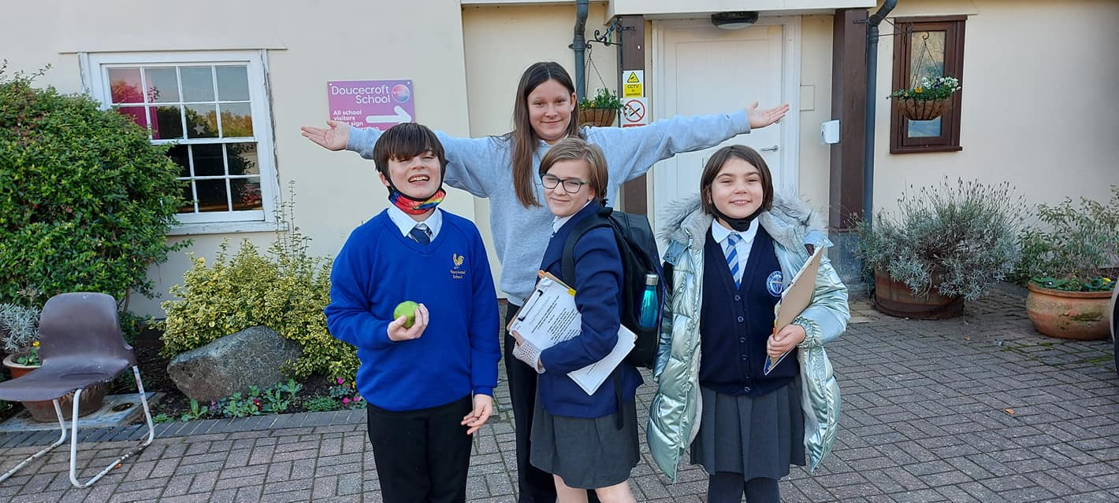

Friendships

Closely behind the mental health impacts was the council’s thoughts about the impact the pandemic had had on children’s abilities to make friends. This issue has also been broken down below;

Play
Children felt their opportunities to play with people their own age had decreased over the last few years due to the pandemic. The consequence of this, they felt, was a lack of skills in how to engage in meaningful play with their peers. To add further comments this was children of all ages who spoke about a lack of skills, where younger children spoke about play, older children spoke about socializing.

Buddy benches
Buddy benches are a way of having a space for children who feel as if they could need some support from a buddy and are usually found on school playgrounds. Different groups elaborated further by talking about zones or rooms that could be used for children who struggle to make friendships.

Setting up friendship groups
Whether this was as part of a lesson, club, or small intervention the children felt schools should have a greater focus on how they support friendship groups to develop. A reflection on small interventions that may have worked before the pandemic could be considered.

Barriers to accessing the community
As part of building friendships some children spoke about the difficulties of meeting friends due to a lack of suitable places to do this or specific needs with a lack transport available. They thought these issues had been made worse by the pandemic.

PSHE support on suitable relationships
Older children within our group felt more needed to be done to educate children about suitable relationships. Where children have been interacting more via technology this may have caused other issues and reduced children’s skills in their ability to make friends in person.

Mix different age groups
A popular idea that came up many times was the idea of making sure children once again could mix with others from different year groups. They referenced to things such as guided reading, mixed seating at lunchtimes and mentor schemes.

Promoting kindness
To support the development of friendships the groups felt the idea of kindness is one that shouldn’t be lost. Schools should look at way’s to promote this both in primary and secondary provisions.

In addition to the feedback we have, as part of our mental health in schools – early intervention awareness sessions for staff, we include these points when thinking about children’s friendships;

- Making sure we understand the child’s communication ability is vital to developing friendships.
- Without the correct communication tools or support, children will often fail to build friendships, complete work, ask for help, communicate basic needs, or make progress.
- Communication games and opportunities to communicate in class are recommended by children.
- Have conversations about various topics that may be of interest to children.
- Make sure we enable to children to ‘check-in’ with each other.
- Include peer role models – children tell us they will often respond better to people their own age.
- Develop our ability to listen – so much of our communication can be focused on talking but the power of listening should not be undervalued.

Respecting everyone’s experiences

The third top theme coming out from the children was the importance of respecting that everyone would have had their own experience of the pandemic. Some children we spoke with were

quite happy at home, learning through technology and built some good relationships with those they were living with. These children may now be finding it difficult to return to school and learn in another way and this must be taken into consideration.

Alternatively, we heard from some children who found it tough being at home and feel that they have lost a big chunk of their education. Consideration towards children’s mental health must be prioritized as highlighted above. Building on this, children felt that people’s personal decisions should be supported and respected – for example those children that still wish to social distance and wear face masks, they want to see schools sending out support for children who still wish to do this and tackling any negative comments quickly.

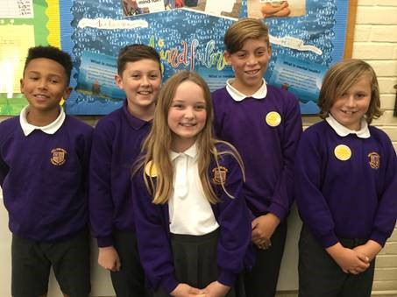

Missing family

Many children have not been able to spend the time they wanted to spend with different family members. Family is very important for lots of children we speak to and ensuring schools have good ways of including families in their school communities was important to children.

They made suggestions such as sharing positive stories on technology tools for parents, getting back to having parents in assemblies and setting up coffee mornings/afternoons. Again, some children wanted professionals to be mindful that some children have lost family members due to the pandemic and making sure we again reflect on mental health needs is important.

School trips

School’s trips were something many children identified as being something they missed over the last few years. They would like community groups to look at how they could organize more opportunities for children to visit their local areas so that children have these experiences again.

They also wanted charities to focus on educational trips for children and make more money available for schools so that they can offer more trips than they ever have done before! A side note on this was to ensue those trips also consider the worries some children may still have about big crowds and the impact of Covid-19.

More Youth Clubs needed

In every part of Essex, children felt there was a lack of things for children to do in terms of active youth clubs. A reoccurring theme was that they felt there were sport opportunities around but clubs that support other subjects or interests have become less and less since the pandemic. They would like more support in finding alternative clubs or to see new clubs created in response to children now wanting to do more.

Testing and vaccinations

Many children felt that it was still important to encourage children and their families to test so that more people can keep safe. They would like to see more campaigns on this in school and would like the government to either reverse the decision around paying for tests or at least reduce the cost.

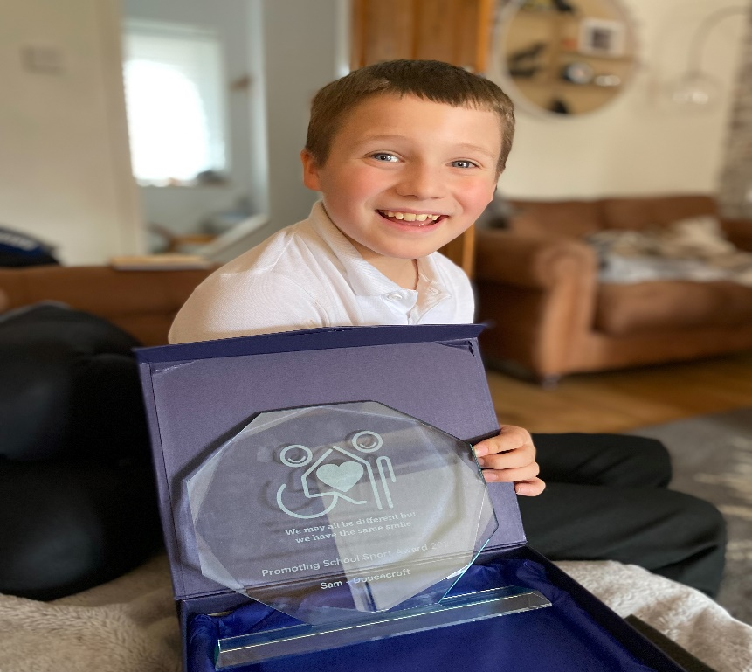

Similarly, they would like to see more information given to children about vaccinations. They would like more information on why people should have and what goes into it. The groups felt there needed to be a bigger campaign on vaccinations or more support for scientists in this country.

Managing busy places

As already mentioned, some feedback we had was that there is some uncertainty among children about busy places. We know from working with children who may have SEN that busy places have always been a challenge for some and what the pandemic has done is highlight some of these challenges for everyone.

The groups spoke about the importance of more places having sensory/quiet rooms for children who may become overwhelmed. Looking at what could support children to manage these places such as fidget toys, ear defenders and other tools, making these more readily available.

PSHE lessons about the pandemic

Some may look at this as being too soon, but many children spoke about wanting to learn about the pandemic. Many children had lots of questions themselves about the impact of covid-19 and felt that it was such a big subject, it would only be right to give children a little more information about it.

Using technology

As mentioned previously some children spoke about learning better through technology, in their own opinion. They would like schools to look at how they could use more technology across all subjects as they said it was in-line with how some children learn. Older children spoke about more investment being made into technology subjects like computing.

Physical health

Not a surprise to us following our work during the pandemic and children wanting more physical health activities, making sure it was a priority for us over the next 3-years. Children spoke about the want to increase physical activities within education following lots of inactivity during the pandemic.

They would schools to consider how much PE they offer as part of their curriculums. They would also like to see more opportunities during break/lunch times and after school clubs so that more children can keep active. Many children felt that more physical activities would also link to better mental health in children.

Hygiene

The children felt that many people were keeping much cleaner throughout the pandemic. Washing hands, sanitizing, and staying home if you felt ill were all seen as positive changes throughout the pandemic. The children’s ask was that this wasn’t now lost!

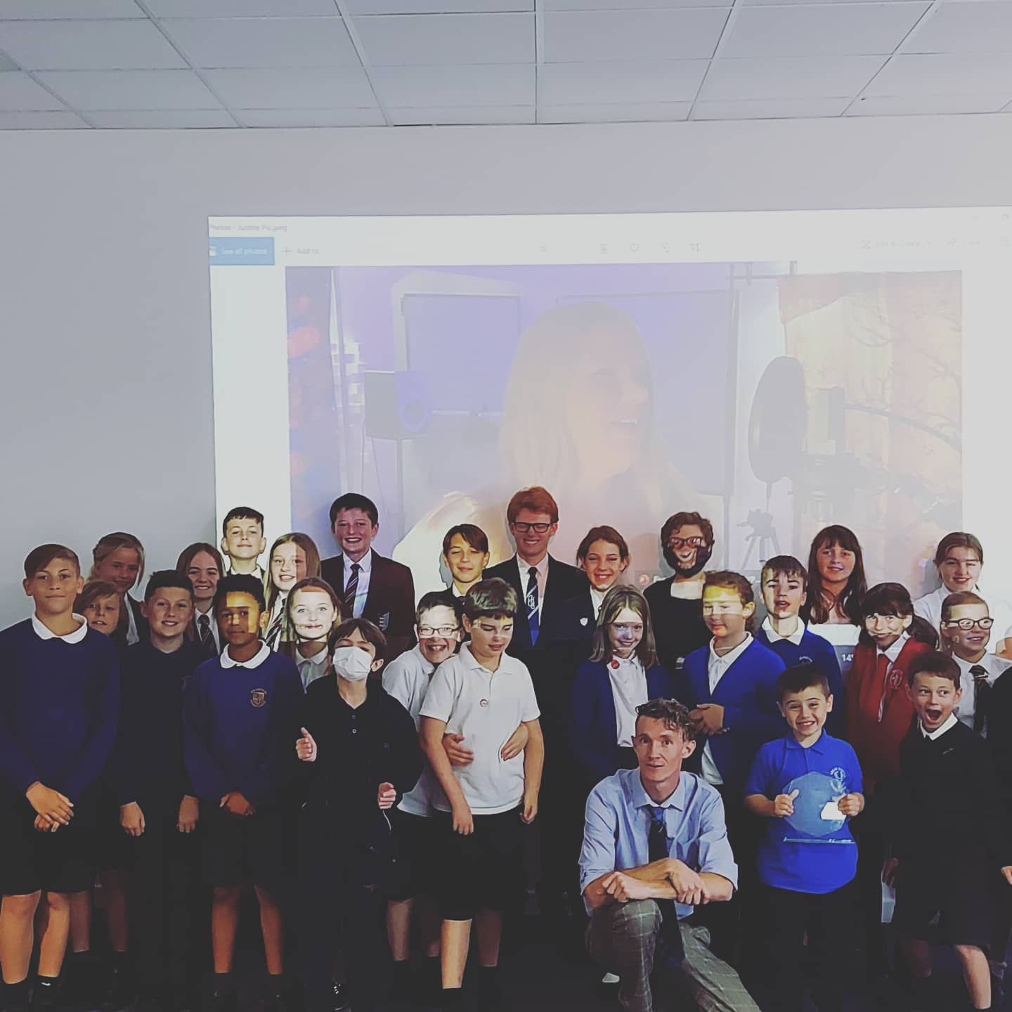

Peer to peer support

Like some of our research has shown before, many children would rather seek support from their peers before coming to a trusted adult. Children felt that many of their friends had been struggling and we needed to explore more ways to help children support each other. As mentioned above they were particularly keen to look at older children working with younger children.

Routine

Many children spoke about the positive impact of getting back into some sort of routine. How routine is explained to children should be taken into consideration using things like visual timetables, now and then boards etc. Where possible the children would like to see more structure and routine put back into place following the pandemic.

Catch up support

Many children told us they felt schools should make catch up support available for some time to come. They felt this should always be optional but takes into account the amount of time children have missed in education. They were also calling on the government to put more funding behind academic catch up support and make sure this money is guaranteed for the foreseeable future not just right now. Lessons such as English and Maths came out as top subjects for catch up requests.

Talk about it

What children didn’t want to see was adults reluctant to talk about the pandemic. They felt children’s thoughts on the subject should always be considered and if a child wanted to talk about it, they should be allowed too. They don’t want to see concerns dismissed just because more things are going back to what we may have seen before covid-19.

Continue to recognize the NHS

The children are asking for communities to still recognize the amazing efforts put in by all the people working for the NHS. Many children spoke about how some support during the pandemic was positive but that this shouldn’t be lost now. They would like to see more people coming together to highlight their work and continue the support for them.

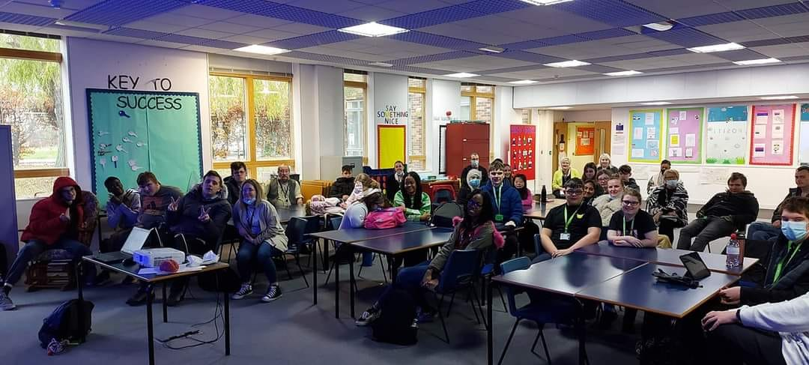

Thank-you for taking the time to read our views on the impact of Covid-19!

Kierran Pearce, Lead for the Multi-Schools Council

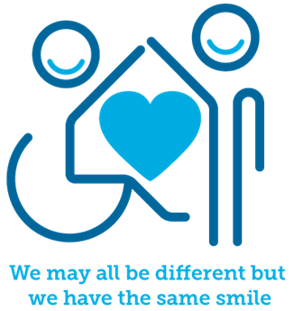

mschoolscouncil@gmail.com

https://www.facebook.com/multischools

Instagram – The_Multischools_council

