The Multi-schools meeting agenda
Braintree
Felstead Primary
Tuesday 22nd November
10am – 11:30am
Clare Graves - Chair
Schools in attendance
Felstead Primary
Great Easton Primary
John Ray
St Peters
ECC virtual schools
Edith Borthwick
Notley Green Primary
Birchanger
Howbridge
ECC SEND engagement facilitator

Apologies – Henham & Ugley (Attending virtual), Bekers Green (Attending virtual), Rose Acres Primary, Wethersfield (attending virtual), Holy Family, John Bunyan, Stebbing Primary (Attending virtual), Southview
Agenda
- Anti-Bullying – How do we raise more awareness of this?
Ideas included:
- A suggestion wall – put our ideas on a wall. Ideas about antibullying, what we think about bullying, etc.
- Draw a picture of Elmer elephant (wo was known to be different) with odd socks and put it on a wall for when parents come in
- Create and edit own videos about antibullying
- Hang some posters around school so people come in can come in and reflect on how they treat others
- Make an anti-bullying song
- Antibullying week – different classes do different activities, instead of an assembly
- Fundraiser and after that we can advertise about antibullying – what if the whole world could see it?
- Popular people on tv shows could do something about it – more people will see it then
- Big posters, they could say ‘no more bullying’ and we could share these in the community
- Develop an antibullying policy in school
- Train staff in antibullying prevention
- A box to share if you are being bullied anonymously – only 40% share if they are being bullying
- Research about bullying and the effects
- Don’t say unnecessary things
- Tell others to stop what they are doing and think about what they are doing
- Put up posters about different types of bullying, how to prevent it and how to handle it
- Rap about it
- Every year or 2 all schools donate money to antibullying charity
- Don’t do antibullying week, do a month to really raise awareness
- Antibullying section in your classroom

- Deaf awareness – What would you like to know?
- Makaton lessons or sign language
- If you are born deaf, how do you learn to pronounce letters and words?
- How do you feel the beat of music?
- How can we help them to hear again?
- What language do they think in? Do they think in words?
- Sign language lessons in schools
- If someone is deaf can we write something down for them – would that help them? Or what else could we do to help them?
- Make classes about hearing and language
- Researching different ways deaf people communicate
- Add captions to tv shows
- Find out about upgrading hearing aids and new technology/ideas. IE, Having microphones in an hearing aid that translates what is said in a way the wearer can understand
- How do they learn in school?
- How do we learn sign language and how we can help them in every day life?
- What % of people in the world are deaf?
- A deaf simulator so we can understand how it feels to be deaf
- Deaf person to come and teach us about what it is like
- Using technology like iPad to communicate with them
- Who invented hearing aids?
- How do hearing aids help people to hear?
- Who was the first person to go deaf?
- How do they learn sign language if they cant hear?
- How do they get answers to questions if they can’t hear?
- How can we raise money for people who are deaf and can not afford hearing aids?

- A multi-schools council Mascot – What should our mascot be like?
- A guide dog with a tshirt that says, ‘good dog, guide dog’
- A big image of our wellbeing badge on a big pillow shirt – it could stretch out and it could say aspire, preserve and achieve
- A monkey because it is harmless animal and maybe all the different MSC school badges on the monkey with words like respect on it
- A penguin – they help and support each other and are part of a community – just like us
- An octopus- school badges on each tentacle – they all come together, like us
- 1 big mascot for charity with lots of little mini mascots
- An elephant made of lots of different animals. For example, the trunk is a shark. They all the MSC school badges in a banner at the top
- A big rainbow. All the different school badges at the end of the rainbow
- A massive teddy bear – who loves fluffiness!
- A cat with a prosthetic leg – smartest animals in the world
- A tiger and zebra together – similar patterns but they are very different. Shows we are all different and similar
- A stripe of the tiger and a zebra – there could be different symbols on it. Like an ear symbol, an eye for blind, etc so it represents everyone. Everyone equal
- Rover dog in a wheelchair – white and blue like MSC logo colours
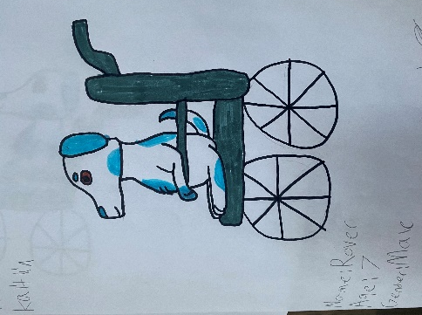 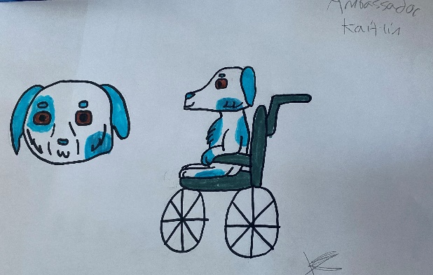
- Gingerbread kid called clove – rainbow infinity sign for Autism
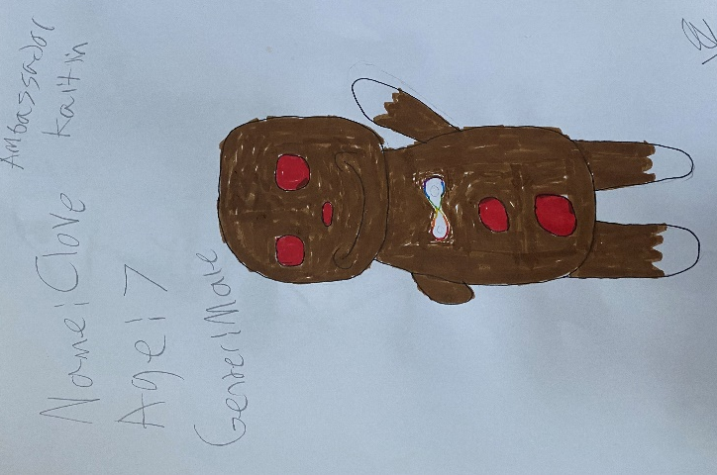
- MSC meerkats- they stick together all the time
- MSC chameleon that doesn’t blend into surroundings – you don’t have to blend in – perfect as you are
- Teddy bear wearing a white t-shirt with all the different schools badges and a heart
- Rainbow teddy bear
- Bird- they all stay in a pack
- The world with people holding hands around it. We are all different but we are all one
- A leopard with spots – but all different school badges/logos on the spots

BREAK

- Money and children in poverty – What are your thoughts?
Things to do:
- Donate to charity
- Donate toys and clothes to children in poverty
- We could do a week where we do activities and raise money
- Quarter marathon to raise money
- Fundraiser
- Twice a year do something like a foodbank
- Youth centre – discuss what to do and money goes to charity to help people
- Football match to raise money for clothes, shoes, etc
- 3 in 10 are in poverty – Advertise preloved clothing online. People can anonymously ask and receive clothes
- Government – write letters to them to ask for help
- Safe place to talk
- Do a foodbank
- Give old clothes away – do it in spring with spring clean
- Each celebration – ie Christmas, Easter, Halloween – we donate £1 to poverty charity
- At school, children in poverty can speak to trusted adult – if you don’t talk to anyone, mental health affected
- Help change mindset – help children to believe they can do anything
- People donate food

Things we want to know:
- How did the children not get any money?
- How do you know a person is homeless and in poverty? Sometimes people pretend?
- Will more people live in poverty?
- Why are the food prices going up?

- Moving on – What would help more young people with moving on into work/new schools/new classrooms?
- Make sure you go to a good secondary school – somewhere to help me with my autism and adhd
- All help decorate new classroom – first day back
- Take something from last classroom and take into next one – something familiar to you
- If moving to secondary and don’t know what it looks like, it would help to have a map, pictures
- Taster day in new school – try yr7 homework, year 7 lessons, meet other people
- Staff and children being welcoming
- If moving to secondary school, meet teacher and students, and look around before starting
- Look at school, classroom or work before
- Area new people to a school can go to. A safe area they can go to at breaktimes. It can help them settle, then when they are ready they can go out and meet other friends
- Give as much information as possible about the new school in an accessible format. For example, what room I am going to be in, time, who is going to be there.. Knowing timetable in advance, open days. Having virtual tours and virtual meetings with staff if not comfortable going into school yourself
- Specific teachers that can keep an eye out for year7s if they are being picked on
- Class buddies from the year above. If scared you can ask someone moving from that classroom
- Lessons in confidence so don’t feel scared
- If too shy to walk to school, maybe a walking buddy
- Make a radio for secondary school and do a show about moving to secondary school – year 7 can talk about their experience of moving to the new school on the radio, and yr6 can listen

Stars of the meeting: Annabel (Felsted), Kaitlyn (Edith), Daisy (terling)

Next Meeting – Wednesday 1st March, Notley Green Primary, 10am – 11:30am
Follow up points
- Can you/do you include some sign language in your school – tell us about it!
- How do you share these minutes with your school – tell us about it!

