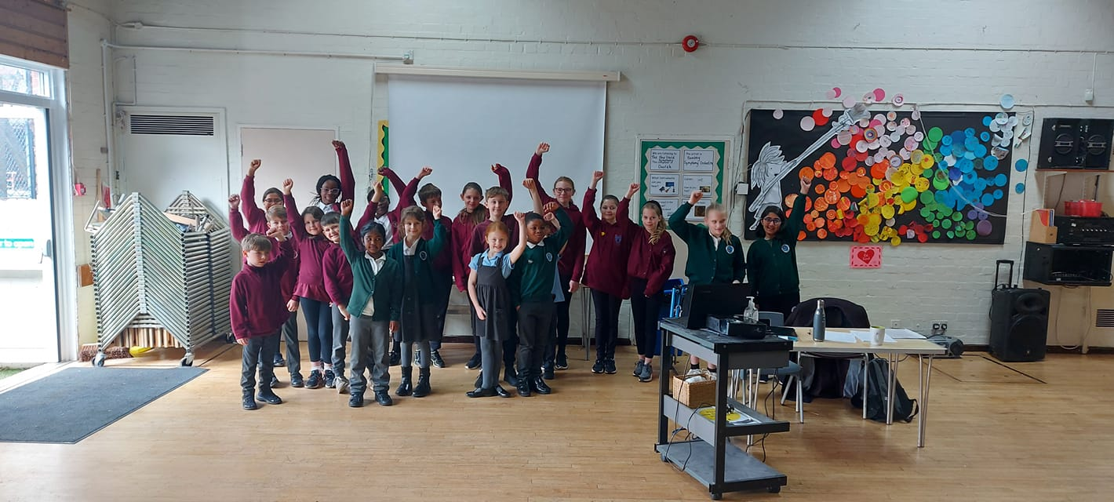
Essex Young People: School Attendance 2022

Why did we write this?

During our work across the county between 2021 and 2022, young people and professionals were highlighting with us some issues around school attendance. Our work is always based on what young people want to discuss and this was another issue they highlighted as one they wanted to speak about.

We spoke with young people across Essex with and without special educational needs and disabilities (SEND). We asked two key questions; What might prevent you or your friends from attending school? What would make you and your friends want to come to school?

The information in this report is what young people want you to know. They hope you can do something with it.

Content within this report includes:
- Thoughts on therapy
- The environment
- Morning activities
- Tackling bullying
- What does anxiety mean? (More added)
- How do you involve parents constructively? (More added)
- Reward systems
- Buddy support
- Flexible approaches
- How to use technology
- Making sure young people are prepared
- Your school councils
- Relationships with adults
- Approaches to uniform
- Clubs on offer
- The use of music
- The fear culture
- The key questions and framework
- Exam stress
- Moving year groups
- Sharing good practice
- Linking in with guidance
- SEND needs
- Going to the toilet

Therapy for young people

When young people are struggling, they have told us they need support in many ways. For some young people a light touch approach may be best as they don’t want to feel overwhelmed or singled out but for others, time to have some sort of therapy can be the difference between a small issue becoming a big one and therefore resulting in a lack of school attendance.

The group suggested the starting point for every school should be – Currently what therapy support do we have in place? Young people gave us some examples of what this might mean:

- Art Therapy
- Music Therapy
- A chance to talk
- Lego Therapy
- Circle time
- Working with animals – not just in primary schools!
- Doing an exercise
- Doing a sensory task
- Changing the stimulus

The suggestions above may not necessarily be seen as typical ‘therapy’ approaches but were all things young people in Essex identified as being a more therapeutic way of working, therefore increasing some young people’s attendance in school. Another important point raised was that therapy can often be seen as a 1:1 or small group intervention but why can’t we make it part of our curriculum? If we know being out of school can affect not only our education performance but more importantly our mental health surely taking time to put these ways of working in place will help everyone.

Young people were keen for these ideas to be proactive rather than reactive to when they are already missing school which supports their idea of making this part of whole class approaches rather than individual support. This was their first key point that they hope highlights the importance of focusing on what could support schools and their environments rather than placing blame on the young person or their family for missing school.

The school environment

Therapy or a therapeutic way of working may be one way of supporting young people in a school environment but what else do they want to see? Having a safe space in a school, often described by young people as a ‘nurture room’, was seen as a brilliant idea by many. Some young people were proud to talk about their environments and we heard about quite rooms with bean bags, spaces with Lego, rooms made to look like kitchens or bedrooms ideal for a chat, calming music, and a space young people could identify with. Do you have a space like this in your school?

Young people felt these nurture spaces were particularly useful for their friends who found school challenging, particularly when changing between groups or when they were already missing school as a more reactive approach.

‘When school is fun, we stay in school’

The exact same quote above was given by two young people, one who attended a primary school and another who attended a secondary school. This sounds like an obvious statement but how often do we reflect on it? Do we promote fun in our schools? Do we gauge levels of fun amongst our young people?

‘When people enjoy their jobs, they often do better, I think it’s the same for us in school’

A common theme for young people on the issue of school environments was outdoor learning. In a previous report written by us (children’s voices on the impact of covid-19) they highlighted the importance of using outdoor learning opportunities. Regarding coming to school, young people think this could really help with more young people wanting to come to school. A change in environment, like using the outdoor space could also be a useful strategy when young people are feeling overwhelmed or are struggling in school.

In the morning…… You know it’s gonna be alright

Young people identified the morning period as being crucial to school attendance. Do we have enough focus on this part of the school day? The group suggested morning ways of working or activities that may help:

- Breakfast clubs
- The daily mile
- Stretching exercises
- Funny videos or pictures on the screen
- Staff who say hello
- A safe space if we need to talk – refer to page 4
- A change over with my parents

Breakfast clubs should be more than just a chance for young people to eat. They could include activities that encourage children to interact with each other, music, a chance to interact with trusted adults. Staff who say hello sounds like an obvious one and surely this must happen in every school. Further down this document we discuss relationships with staff but in our meetings with young people some said they were not acknowledged as they came into school.

Given that the morning period is our first chance to make a positive impression on the young people in our care, it’s an area that we really should be considering as part of school improvement. Young people said that in school there are expectations they must follow, and they feel like they need to make a good impression but what about the impression we need to give young people about the environment they are walking into. How do we do that?

Bullying

Young people gave bullying as the number one issue on why they or their friends may not attend school. This led to further conversations about children with special educational needs and disabilities, and gender differences/preferences which are covered in some of our wider pieces of work. When issues with friends aren’t picked up this can quickly spiral and result in young people not wanting to come to school, from what they told us. The issue was not reserved to inside the school gates but also through social media and the impact messages and comments can have on school attendance.

Young people asked us how they can be involved with preventing bullying and so we are adding it to our Multi-Schools Council agenda for the new academic year and it will form part of our autumn term meetings. As a starting point young people want to be involved in the writing of their school bullying policy – do you do this? Could you ensure school councilors feedback on this?

When we use the term early intervention in relation to this young people have said it means dealing with ‘banter’ more effectively. When comments are sometimes classed as just being ‘unkind’ or ‘banter’ this can then sometimes lead to more serious problems if the right systems are not put in place. Young people said bullying from peers resulted in:

- Higher levels of anxiety
- Feeling like they are going to be sick
- Not wanting to go onto the school playground
- Fear of getting things wrong in lessons
- Not having the confidence to ask for help
- Not having any friends

Some of these issues are focused on in more detail later down this document.

Anxiety

We spoke to some young people as young as 7 who were using the word ‘anxious’ to describe how they might be feeling about their school experience. Although some may see this as progress in terms of emotional literacy for younger people, we could also look at what does this word mean for different groups? What do the children in your school understand anxiety to mean?

If we fail to understand where anxiety comes from, we may always fail to keep some young people in school. Young people we spoke to said that we must explore what is making young people feel so anxious, especially when it comes to school. This is where young people were suggesting a more proactive approach because they had examples of friends who had said they were feeling anxious for some time and from what they could see nothing was done so now they are off school which leads us to the question, how are we intercepting early anxious thoughts? There were no general statements to be made on this issue as many young people felt it was very individual but that we did need to look at what does anxiety mean to young people, which could be a piece of work for other professionals.

Looking further into this with families we know that some professionals are failing to see ‘anxiety’ on par with physical challenges. If we are committed to ensuring that both physical health and mental health are seen with the same level as importance, we must then respond in a balanced way to young people’s challenges. We know from our meetings that anxiety levels are usually higher in those with SEND, often because they feel misunderstood or because needs are not being met. We know from our research following this report that young people with SEND are more likely to miss school or become excluded, which again points back to further understanding needed in all areas of SEND awareness and the impact on young peoples mental health.

Involving parents constructively

How are your parents actively engaged within the school community? As a starting point young people wanted us to highlight this question in relation to more than just school attendance. Where parents could work constructively with their schools, young people said it gave them a better chance to stay in school whereas when these relationships became strained it made it harder.

Young people said that when other people became involved in their attendance this made it harder for several reasons:

- Parents started to become worried about fines rather than supporting them to get back into school
- They fell out with members of staff at the school which then made it harder when returning to school
- Some of the language used in letters really upset their parents
- When relationships broke down, they felt their parent’s mental health suffered
- When outside groups got involved, it felt like they never speak to us about why we are not at school or what we might need

Money and poverty are other key issue that young people are starting to talk about which is why this will also feature as part of our Multi-School Council meetings. Some young people felt that it was very unfair to talk about fines so quickly when lots of people are already struggling with money. The outside groups were explained as ‘attendance solutions’ and overall were not very constructive in how they supported young people back into school. The young people we spoke to said that some groups had completely the wrong focus, trying to punish them and their families rather than looking at how they could work with them to get them back into school. The whole piece on parental engagement starts with how schools develop this positive relationship from the start and the young people felt like good communications, signposting to support groups and coffee mornings were a good start.

‘Get the parents onside from the start’

During covid we did a lot of engagement work with young people and one of the clear messages that came out was how important family was. As professionals we can reflect on, how important is family to us? From speaking to young people now we know that many of them have different situations that they may be balancing at home – being a young career, dealing with a family break up, welcoming a new member of the family etc. Some schools are very good at understanding the whole family picture and we spoke to some young people who were full of praise for their school’s family support team. When things may be difficult at home young people would like to see:

- An acceptance they may need to use a phone and check in with a family member
- If phones aren’t available develop another channel of communication that can be used
- Have a key member of staff they can talk to
- Have a staff member that may be able to do a home visit

Some young people felt frustrated because some parents were unable to attend certain meetings due to health needs or not having the right technology for an online meeting but were then still penalized by different attendance groups. They wanted to repeat the importance of having parents engaged in the school community so that this relationship is positive and effective.

For some parents they can also feel very anxious about school attendance and is if they have no power. In some cases, parents have spoken about feeling intimidated by professionals or almost forced to send their young people to school even when it’s against their wishes for various reasons. Parent groups we have spoken with have been working on making sure parents have the right guidance and understanding when it comes to school attendance so that their can be fair expectations. Constructive conversations are always better for the young person and these groups have been looking into these skills also. Attendance can evoke emotions amongst different levels of people and as our young people told us it is important that we don’t let emotion cloud our judgement from what’s best needed for everyone.

Rewards

(Young Person) Our parents get paid to go to work.

(Adult) But you go to school to learn so that you can work.

(Young person) Do you think that makes me want to go to school?

(Adult) It should do.

(Young person) Well, it doesn’t.

This is how a conversation unfolded on our travels and was reflected in other way’s during our meetings. It raised some important points linked to idea of rewards that young people were keen to mention. Is the fact that young people go to school to get a good education and progress into the workplace enough to get most young people through the school gates? The young person here highlighted the fact that adults get paid to go to work, which for some is a big incentive, but are our incentives enough for young people in schools?

Young people, both in primary and secondary settings, consistently used the term ‘rewards’ rather that incentives but felt it was crucial to ensuring their attendance in schools. Examples of this from young people included:

- Reward sessions throughout the week
- Individual awards, not about how much they come to school but more about what they do while at school
- Attendance certificates can be counterproductive because there can be many reasons why young people don’t come to school
- Time with senior leaders in schools
- Involving us in the planning of our reward system

The point about not handing out attendance certificates at the end of the term or school year came up more than once. Some young people spoke about their friends who had missed ‘a lot of school’ because they had a family member who had passed away or they became very ill themselves which was then still reflected in their school attendance. Although we would always encourage the importance of being in school, we would also accept that some things are beyond our control and when this is not recognized it can again grow the levels of frustration around school attendance issues from both young people and their families.

Having the chance to talk with and spend time with senior leaders was another suggestion that came up several times. Many young people did see this as a real reward and a reason why some young people may then feel more comfortable to come to school. As a senior leader when did you last spend some quality time with a group of young people? We hope throughout the report you can identify the golden thread of pupil voice and in terms of reward systems, young people feel they should be involved in the design stages of this as they are more in touch with what may help young people want to come to school. The big shift we could identify from young people here was moving away from the have to come to school, to a want to come to school.

Buddy support

We know from our previous work with young people and the consistent messages we get from them are that in times of challenge they will often seek out their friends before coming to an adult. Therefore, young people were asking how they could support their friends to come to school as well as suggesting some ideas to consider:

- Have a supportive friend waiting for a young person who is struggling to come to school
- Having a peer network they can communicate with through technology – more on the use of technology to follow
- Worker harder on building friendships in the classroom
- Have young people manage the nurture rooms and safe places in schools
- Think about using young people constructively on visits to the home

Much of this has been reflected in our previous report on returning to school after covid-19 but is now more specifically related to school attendance. Some of the ideas
suggested above could be simpler to implement, whereas some may be more intuitive ways of working. Our pupil voice reports are never diluted by adult opinion as this is not the way we work but we do appreciate safeguarding and the needs of others need to be considered but if this can be done successfully, who’s to say we can’t have teams of young people on visits encouraging their friends to return to school?

‘My mum said children always have the best ideas because sometimes adults are scared to say what they think or come up with different ideas’ (we agree)

Being flexible

Young people have already identified in some areas of this report that school attendance can certainly be an individual issue. If we accept it can be individual, then we know that a one size fits all approach probably won’t work. Young people said they felt frustrated, sad, and let down when schools were unable to be flexible. Their flexible comments were in relation to:

- Not adapting start or finish times to meet individual needs
- Lessons that were not flexible in terms of individual understanding
- Understanding young people with special educational needs and disabilities
- Understanding young people with mental health challenges

The first bullet point speaks for itself but in terms of lessons this was about how some young people failed to understand the content of lessons, or tasks were too hard, they didn’t get the right support, so they then decided not to come to school. In terms of the final two comments, this reflected on levels of staff training. Where individual needs were not met, young people felt like they couldn’t access school. We would be interested to find out how many young people who are not attending school have special educational needs and disabilities or are experiencing challenges with their mental health. This type of data may then link to the idea from young people about better understanding in the first place to meet need which would again be described as a more proactive approach.

A key question from this area of the report was, is your school open to adapting start and finish times for some young people?

Using technology

Further information on how young people feel technology could be positively used in school’s forms part of our covid-19 report on our website but is also relevant to school attendance. During our meetings a few schools spoke about the use of robots in their classrooms and how these were being used to engage some young people from home.

Young people were asking us the question that how come during lockdown we were able to use much more technology but now when some young people might still be struggling to come to school, we cannot use it? Zoom calls were seen as popular, some young people even suggested that as part of their nurture rooms (further information on page 4) technology could be linked up so that those not in school could feel part of a group as a way of helping them return. Technology in terms of school attendance was certainly described to us as a more reactive form of support but they wanted schools to consider, how do you use technology to engage with young people who are out of school? As a Multi-Schools Council, we have also listened to young people and from the new academic year (2022 – 2023) we will be holding meetings once a term for young people who are out of school for whatever reason as their voices are crucial to projects like this.

Preparation

How do we prepare our young people to come to school? Although our meetings include young people of all abilities there was a particular focus from young people with SEND about the importance of preparing them for school. The group had some suggestions in relation to their key points;

- Visual timetables in class so we know what is happening
- Providing us with a forward planner of key events or changes that might be coming up like you do for parents
- Having a flexible approach to homework
- Updating our paperwork so you know things about us
- Make reasonable adjustments in class

There were many comments on this subject about how young people wanted adults to reflect in their need for preparation such as, would a teacher come to a lesson not knowing the subject they were teaching? Would they feel comfortable knowing nothing about the class they were teaching? If a teacher taught in a certain way would reasonable adjustments be made? Young people felt that the same expectations should be there for both themselves and adults. Interestingly, in many of our staff mental health training sessions, we ask adults what helps them to feel safe and normally the top answers are things like knowing what’s happening or having a plan. From everything we heard and know about young people, they need that plan too.

We meet with young people with all kinds of differences and so the other important point in this section is that how you communicate changes to young people can very much vary depending on need. For example, some young people told us they benefit from verbal information whereas others may need more of a visual approach to information. The example we had was that a visual timetable outlining the plan for the whole day may work for one so that they feel completely prepared, whereas for another young person they may feel completely overwhelmed by that and could benefit from a now and then board which is breaking down the day.

Pupil voice forums

We hope the golden thread throughout this report is the voice of young people. In relation to school attendance, they felt having more of a voice within the school gates would help keep them within school. They wanted school to reflect on how they engage with young people and again suggested some ideas on how to do this;

- Setting up an SLT group of students
- Having a school council that directly links to the headteacher
- Do surveys within your own schools about school attendance
- Let young people lead their own discussion groups with each other

As part of working with young people on this piece of work, they also wanted to ensure schools knew what channels were available to enhance young people’s voices in their communities. As a multi-school’s council our aim is to always give young people with and without SEND the opportunities to speak out but also signpost to other organizations and as part of our whole piece of work on school attendance, we will look to do this.

‘When we feel like people listen to us in school, we want to stay in school more.’

Relationships with staff

We know some young people see school as a great opportunity to make friends and be social whereas others, who may have experienced bullying or trauma in school, can hate it. The same can be said for those young people who have positive or negative experiences with staff. Some young people were telling us they still felt that they were being asked to respect staff members without getting any respect back. Some young people again referred to the workplace and said that if colleagues or managers weren’t respectful towards you would you want to work for them?

As many young people explained to us, they understood the need for a balance and a need for rules and expectations. But just like a code of conduct for young people they want to see a joint code of conduct rather than making it about us and them. They felt schools that took time to work on their relationships between staff and young people had a better chance of not just keeping them in school but also helping them to enjoy it. A common theme was the need to start from the top, some young people wanted good relationships with headteachers, and other senior members, not just be distanced from them and unable to have their voices heard.

‘I want the people who run schools to care about us’

Approaches to school uniforms

One barrier for some young people attending school was the rules around school uniform. Some young people we worked with had been involved in their uniform policy and therefore felt more young people accepted it and didn’t see it as an issue. For others we spoke to it was the difference between coming to school and not. In the meetings it was raised, it did offer debate and many young people accepted there were many different views on the issue. To add further context, the point was raised in both primary and secondary led meetings.

There were three key points that we kept coming back to;
- Most young people said they learnt more when they were comfortable – some young people with SEND were very receptive to different textures and materials which impacted their concentration levels – they wanted to know is this a reasonable adjustment that can be put in place?
- Both genders did mention issues around body image, especially in relation to PE and changing – some young people said that on days of physical activity they didn’t want to come to school due to this – is there support with these kinds of concerns?
- Have young people in your school ever been involved in the uniform policy?

Young people were interested to find out how many schools in Essex have a set uniform and how many may allow young people to wear what they feel comfortable in. We had both groups were represented in the meetings and generally those who said they had more control over what they wore to school said it impacted more positively on their education.

Clubs

In our Covid-19 report, that we have referenced more than once in this report, young people highlighted clubs as a big positive in terms of helping young people get back to school. In terms of general conversations around school attendance clubs also came up again including both after school clubs and as part of the school day. In relation to after school clubs some young people said that even if they had some lessons that they found challenging or maybe didn’t like, the thought of a positive after school activity was enough to get them into school.

Other young people we spoke to wanted schools to focus on their offer of clubs during the school day. This was because some young people said after school was not option for them for a range of reasons including:
- Lack of transport
- Family responsibilities including looking after siblings
- Too much sport on offer and not enough variation
- Cost
- Not being with friends

They felt having more a varied offer in the school day solved these issues and had a positive impact on school attendance. The group wanted schools to consider what does our current school club offer look like, and could it be improved?

Music…..Sing, sing sing!

How do we use music in schools? An interesting angle that came up within this piece of work and maybe one that not many adults would have predicted would feature. We heard more than once about the impact music can have on school attendance. Music, some felt, had a positive impact on young people’s mental health and therefore improved the overall experience of school life.

Young people wanted schools to consider key questions such as do you have music in your corridors? Do you use music as part of your lessons? Could music be part of your therapy approaches or nurture rooms? It was clear that at times young people felt music could play a real positive roll in creating a better atmosphere among them and their friends.

The fear cultures

A sad but reoccurring theme was young people’s views on the ‘fear of failure culture’ amongst some of them and their friends. Young people felt that this was another key reason why some young people didn’t want to attend school due to worrying about failing at something. It was clear that some young people really did view schools in the complete opposite way in what I am sure all professionals would want them to.

Some young people spoke about feeling like they had to constantly perform, like they were being compared to their friends and other schools, that they always had targets they had to reach and that if they didn’t understand something they couldn’t ask as they would look stupid. As some of the young people pointed out, surly school is about making mistakes so you can learn from them, developing at your own pace, focusing on what’s important for your own development and being able to ask for help. These fears, some went on to say, dramatically affected their mental health. They wanted people to consider this question – is there a fear culture in your school?

Exam stress

Since our first publication we have heard from more young people and those working with them that exam stress may be another reason that reduces school attendance. Initially we believed this focused on GCSE exams, but we know this is also affecting young people in primary schools with their SATS.

Firstly, looking at how SATS young people asked the question how much does this affect my future? Young people were asking for honesty around this because this may help to reduce the pressure and stress that can be placed on young people. Do we hold these open conversations? This is not about de-valuing exams (even though their importance does split opinion) but about better explanation and preparation, helping to reduce the stress.

Young people we spoke to also accepted that ‘testing’ was a part of life and there is a need to prepare young people and understand where they are at. Developing young people’s resilience levels was seen as crucial here from themselves but other professionals we spoke to who work within secondary school settings. It may be a time to look at what resources are out there for building resilience in young people, the MSC also has produced some resources on this subject which can be found here https://schools.essex.gov.uk/Pages/Search-Results.aspx?k=resilience or you can email us for further information. Wrap around support during these times is key and we would ask you to reflect on the other areas of this report.

Moving year groups

This part of the report is called moving year groups rather than ‘transitions’ as we have found, more so with secondary aged young people and different professionals, that the word ‘transitions’ carries other meanings, and we need to be specific with our language. Our feedback in this section was gathered while working alongside the Essex virtual schools’ team during our winter 2022 MSC meetings. There were some key points to pick out:

- Longer time in new classes when moving between year groups to support with the change and feeling more prepared
- Put a ‘moving on’ buddy system in place which will ensure older young people can support younger
- More time with new adults to help build relationships
- Videos of new environments
- Less pressure on the ‘grades’ we must get in the new year (a carry on from the section above)
- Non-uniform on moving on day’s
- Know where the safe space is in school (refer to our environment section higher up)
- When moving to new schools make sure they see the whole school
You can see there was a wide variety of feedback from young people on this subject. With our school awareness sessions in schools, we tend to talk a lot about the importance of preparation and giving time. This was clear in every part of Essex and a common theme throughout this question. It’s important that strategies we use for young people with SEND are also reflected on when it comes to change, this is what our young people were telling us.

The idea of a buddy support system was also one that stood out. This started with our secondary aged groups talking about the move from year 6 to year 7 and the support they would like from older students. They want schools to reflect on ‘How do use your older year groups to support the younger year groups with change?’. However, this was not just about the new year 7’s it was also about year groups within primary schools and how the KS2 cohort may support the KS1 groups. Many of our older groups understand there is pressure on staff time but that with attendance sometimes the answer lies within the young people themselves.

Another reoccurring theme was the importance of relationships with staff. They wanted adults to reflect on how they might feel when they join in a new team or when someone new comes in to work with them and the importance of getting to know. With class sizes rising young people understand that this is not easy but that time with new teachers and supporting adults to get to know them is crucial. A simple suggestion was fact sheets about staff like we have when young people so that they also know who they are working with in their new classes.

Sharing good practice

A challenge from our young people was how do schools share good practice when it comes to attendance? We know from speaking to young people as part of this work there is good stuff happening, but they don’t think we share that enough. We know schools used to compare themselves based on exam results but is that really the most important comparison? Comparisons could be made on how schools ensure young people want to be in school. An outcome they would like to see from this is a better system to sharing practice which is why we have now included a 2023 framework (see below).

Linking in with guidance

Part of this evolve document now includes advice and support from professionals working within different attendance teams and roles. The department for education also has a strong focus on improving school attendance levels and some of their recent guidance does link in with the suggestions within this report. We have picked out three main points:

- Ensure there is enough SEND awareness within your school teams. We know from the data that young people with SEND are at greater risk of missing school or becoming excluded and there is a need to increase awareness. Through the MSC we help develop SEND awareness in schools but much more is needed and regular updates and an individual approach to school attendance is crucial.
- Making sure schools work with school governors is also very important when it comes to school attendance. Do you ensure governors understand their responsibility when it comes to school attendance? Do your school governors work with staff and young people to understand the needs when it comes to school attendance? When it comes to school exclusions are the school governors trained and up to date with policy?
- Useful links for schools to be aware of to help support parents:
- Coram’s Child Law Advice service
- ACE education
- IPSEA
- SEN IASS
Making sure local and national links is crucial to supporting attendance. Look out for Let’s talk: We miss you guidance, which will be available on the Essex info link.

SEND needs

It was clear from our first round of conversations that certain aspects of school attendance came out strongly from those young people with SEND. Since then, as mentioned further up in this report, we have done some further reading about SEND young people missing school and the higher numbers compared those young people without SEND.

One area of concern was the need to address unmet sensory needs in school. In your own school or setting do you do enough work on understanding CYP’s sensory needs? As we heard from young people during our first round of meetings when they feel overwhelmed or misunderstood within a setting they don’t want to come in and may not have the skills or understanding themselves to explain this. Encouragingly we did hear example of good reasonable adjustments for other areas of need such as ADHD or some mental health concerns but that more adjustments for young people with autism could be made. A lot of good autism practice looks at the school environment which in turn then helps to support individual sensory needs but obviously not always.

“When children are not in school, they end up falling through the net”

The quote above comes from a recent children’s society report as do the facts below:

- Young people with special educational needs (SEN) are up to five times more likely to be excluded from school if they have no specialist support.
- Many young people with SEN end up becoming isolated in schools which in most cases effects their development and their school attendance.
- A recent study shows that exclusions and isolation to more harm than good and in many cases result in mental health concerns.

Going to the toilet

Another area that we have had some feedback on since the first report was published was school’s different approaches to young people using their toilets. Some young people we spoke to felt that there was very little flexibility around individual needs and although some young people understand their does need to be some rules around toilets and when you can go, in the same breath they would like to see some flexibility.

We know because of some young people’s understanding and needs that they don’t feel the urge to go to the toilet until they are desperate, and this can then be hard to manage during lesson times for example. The pressure of toileting we have heard can be enough to put some young people off coming to school. For some secondary aged young people this has resulted in them having toilet accidents while in school or ended up receiving a detention.

Key questions and continued work

Finally, the young people who influenced this report would like to highlight some of the key questions they have stated throughout the report:

Currently what therapy support do you have in place? – Refer to page 3
Do you have a safe space in your school? - page 4
Do you have enough focus on the start of the school day? – page 5
How do you involve young people in your bullying policy? – page 6
What do the children in your school understand anxiety to mean? – page 6
How are your parents actively engaged within the school community? – page 7
As a senior leader when did you last spend some quality time with a group of young people? – page 9
Is your school open to adapting start and finish times for some young people? – page 10
How do you use technology to engage with young people who are out of school? - page 10

How do you prepare your young people to come to school? – page 11
Have young people in your school ever been involved in the uniform policy? – page 13
What does our current school club offer look like, and could it be improved? – page 13
How do you use music in your school? – page 14
Is there a fear culture in your school? – page 13
How do use your older year groups to support the younger year groups with change? – page 15
In your own school or setting do you do enough work on understanding CYP’s sensory needs? – page 16

Or use this suggested framework below (MSC attendance framework 2023)

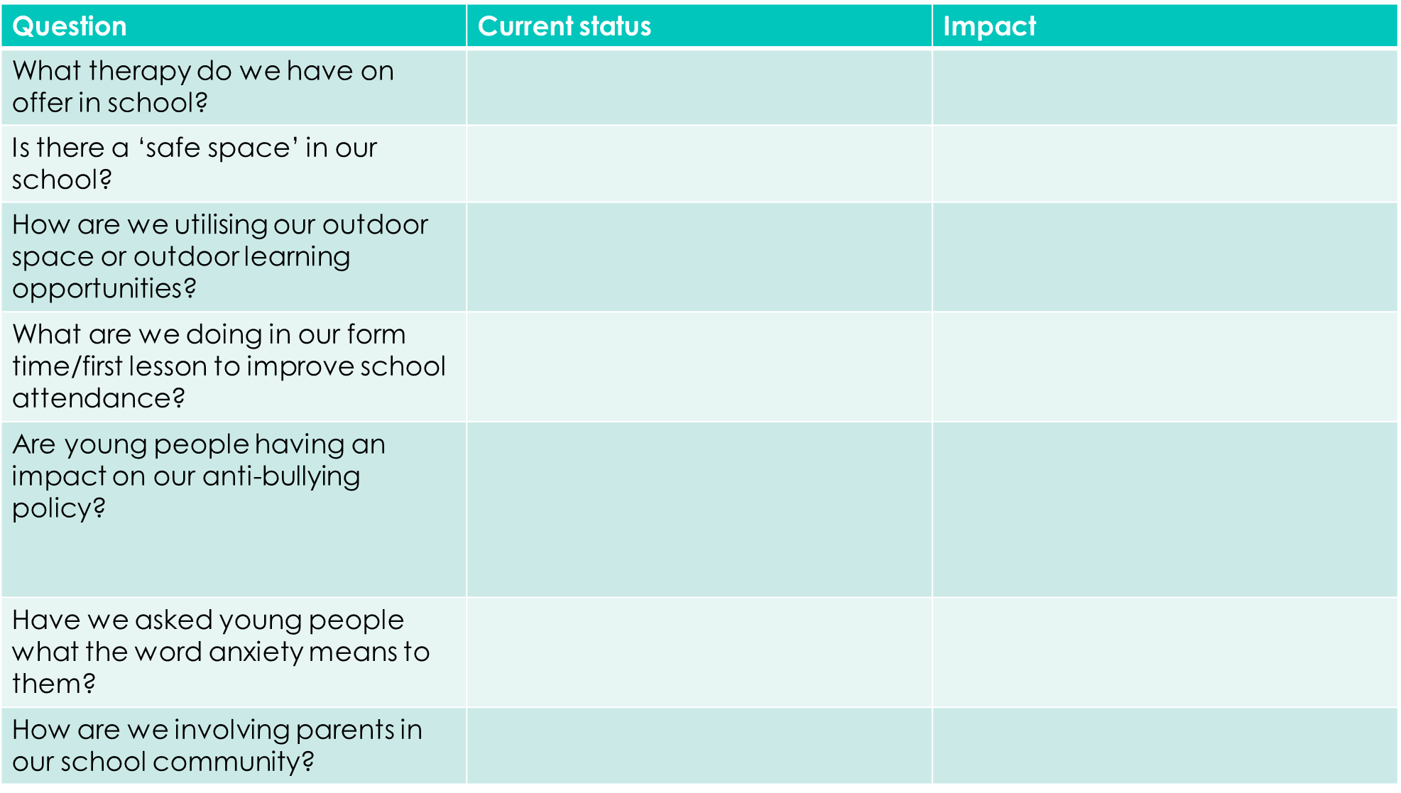

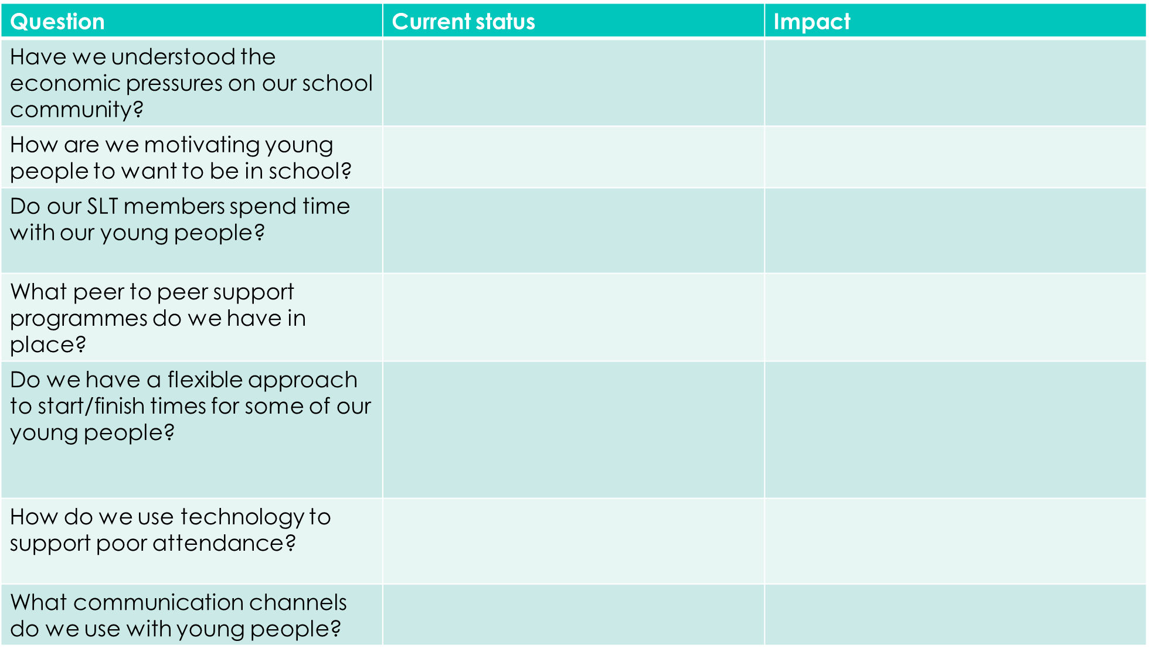

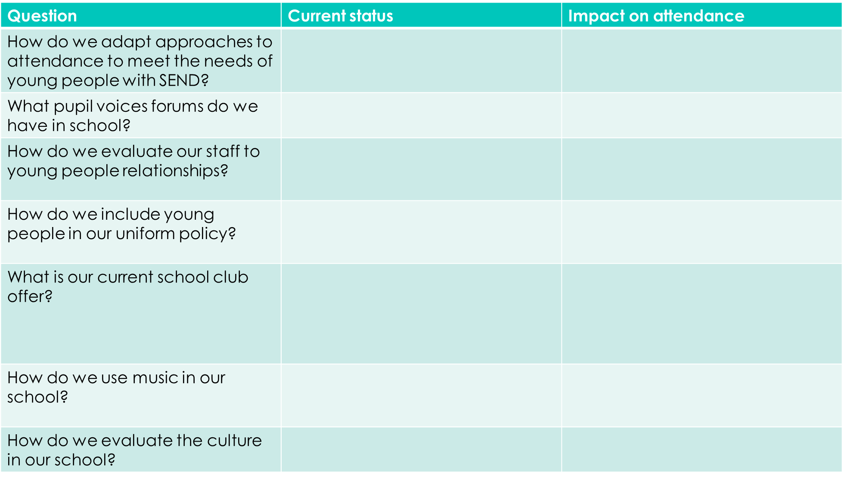

To get in touch please use our mschoolscouncil@gmail.com OR kierran.pearce@essex.gov.uk email address.

