The Multi-Schools Council – Medium term plan
2023 – 2025 (End)

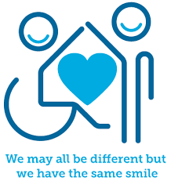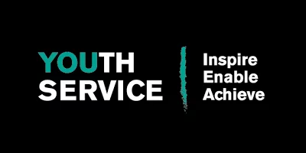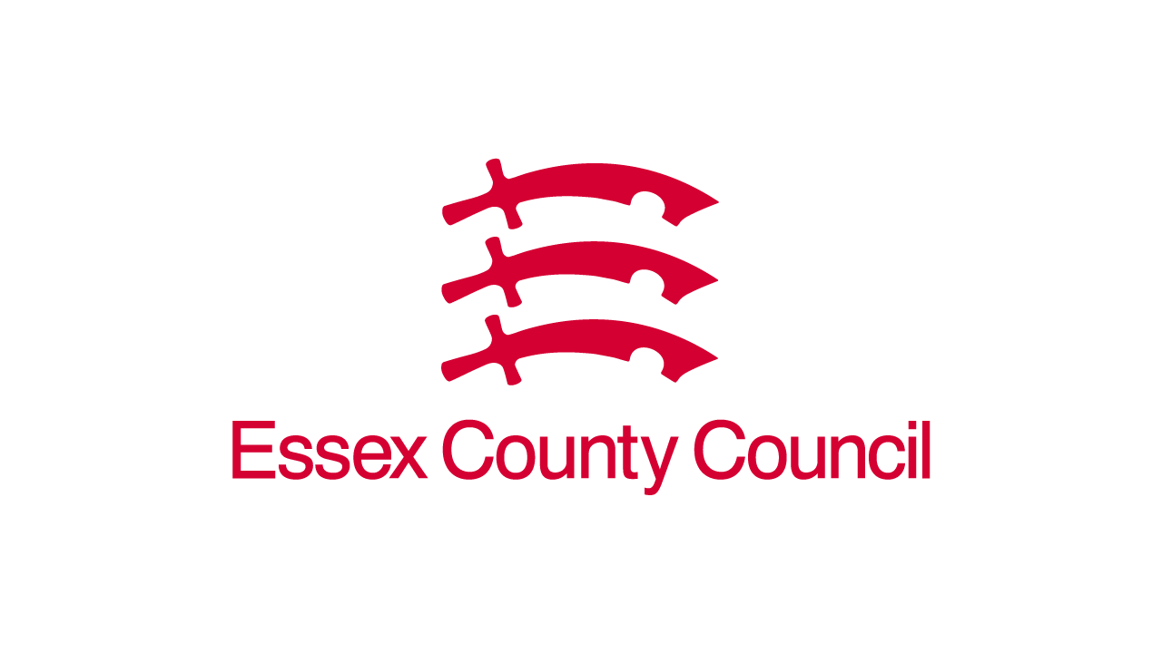

This plan has been produced after the successful agreement during the summer of 2022 to permanently fund the Multi-Schools Council (MSC) work and put it alongside the Essex Youth Service (EYS). The council is being funded through a joint commitment that involves education, social care, and health.
This plan has a heavy focus on Essex as we look to enhance our offer to young people, challenge more perceptions within our local area and better measure our impact. During the summer of 2023 we will also be producing a long-term plan that looks to focus on the surrounding areas of Essex, using this template of work and applying it within other local authorities. We must be open and flexible to the direction of our council, ensuring every opportunity to grow and enhance our work is explored.

Introduction
Taking our work back to its basic principles:

‘To challenge negative perceptions towards young people with special educational needs and mental health challenges’ – Established 2012
Within those 10 years of building the MSC the core aim has now evolved into:
‘Promote positive perceptions towards young people with special educational needs and mental health challenges’ – 2023
The language shift reflects where we believe our work to be at. The positive progress we have been able to contribute towards means that SEND and those with mental health challenges are slowly becoming better understood and accepted – although there is still a long way to go!
This plan will be looking at some core elements of our work and the crucial parts of our success to reach the aim above:
- Focus on our Essex Education offer, enhance it, make it more diverse and target the areas we need to.
- Measure our impact, explore options, create a structured criteria for our work.
- Build our work into Essex Secondary Schools, explore exposure and links within the wider EYS.
- Develop our ambassador programme, increase visibility of their roles, and set a framework of expectations.

Education
We know that our work within education is paramount to the impact of our work being felt. However, we are also aware that when we work within education this just does not solely mean education teams and partners. Within this area of work, we must also work with and refer to health and social care teams who will be crucial to the success of our work.

Links to local and national guidance
The National Youth Work Curriculum (2020) - https://s3.eu-west-1.amazonaws.com/assets.nya2.joltrouter.net/wp-content/uploads/20210414232918/5.3.1-0923-NYA-Youth-Work-Curriculum-DIGITAL1.pdf
Our work within education offers informal learning opportunities for young people to understand SEND – Links to page 9
Young people are not the ‘problem’, the problem points to a lack of education about our differences – Links to page 10
We need to challenge oppressive attitudes and behaviours towards young people with SEND and ensure they have confidence in their own abilities – Links to page 12
Through education, help young people explore and understand their identities – Links to page 16
We must work with all relevant professionals when it comes to the best education for young people with SEND – Links to page 26.

The children and families act (2014) - https://s3.eu-west-1.amazonaws.com/assets.nya2.joltrouter.net/wp-content/uploads/20210414232918/5.3.1-0923-NYA-Youth-Work-Curriculum-DIGITAL1.pdf
Improve the quality of education for young people with SEND through understanding and differentiation – Links to Part 3, point 25 (1) B

My life, my rights, Essex local area SEND strategy (2022 – 2027) - https://schools.essex.gov.uk/pupils/SEND/Documents/9456%20SEND%20Strategy%202022-27%20ACCESSIBLE.pdf
All children and young people in Essex deserve a high-quality education regardless of SEND needs – Links to page 3
Young people’s views and thoughts need to be included when ensuring school inclusion – Links to page 11
To ensure understanding of SEND needs we need to work together as a whole system – Links explicitly to page 15
The rhetoric around ‘SEND’ is often negative and we play a key role in educating against this – Links to page 38

The United Nations Convention on the Rights of the Child (1990) - https://www.unicef.org.uk/wp-content/uploads/2010/05/UNCRC_united_nations_convention_on_the_rights_of_the_child.pdf
Every child has the right to express themselves – Links to article 12
Every child has the right to an education – Links to article 28
Education must develop every child’s personality, talents, and abilities – Links to article 29

Core aims:
- Continue to work on our existing offer to schools while working with our ambassadors to enhance our sessions. This includes ADHD workshops for young people, Autism workshops for young people, Autism sessions for staff, SEND assemblies, mental health assemblies, mental health training for staff and speech and language training for staff.
- Explore how a digital platform that includes a ‘learning hub’ will add greater sustainability to our offer.
- To develop an offer around Anti-Bullying that will complete our existing work within schools. This will be developed in collaboration with individual ambassador groups.
- To launch an intro assembly aimed at raising visibility of our service and the work of the MSC ambassadors.
- Explore the areas of sexism and racism with our ambassador team and look at how we can support understanding based against these areas.
- Continue to use sport as a driver towards positive perceptions of young people with disabilities. This will include the continuation of our special school games, the keeping active priority set in 2021 and the disability sports awareness session created by two of our ambassadors.
- Hold another vote within our MSC meetings (2024) to agree a focus on three further topics moving forwards. This will include data gathered from within the wider EYS and be based on local feedback.
- Include the work of our rare syndrome ambassadors and link in with schools around physical differences. This will be included with the development of our SEND assemblies and anti-bullying campaign.
- Launch a MSC survey linked to the priorities within education set by our CYP and help to close the feedback loop.
- Continue to produce reports (where appropriate) linked to the key themes highlighted by CYP across Essex.
- Develop our links and work within the alternative provision space and build on our project linked with SEND IASS, while also considering how we include young people who are educated at home, linking in with social care teams.
- By the end of the 2025 be working across a district model, splitting the engagement groups (where appropriate) between primary and secondary groups.
Our 2022 – 2023 school offer

Our 2023 – 2024 school offer (next page)

Our 2024 – 2025 school offer

The school offer work will be reviewed at different stages linked to our ‘impact’ area below. To ensure the successful, high-quality delivery of these sessions we will need to ensure the correct training is given and review staff capacity at every stage.
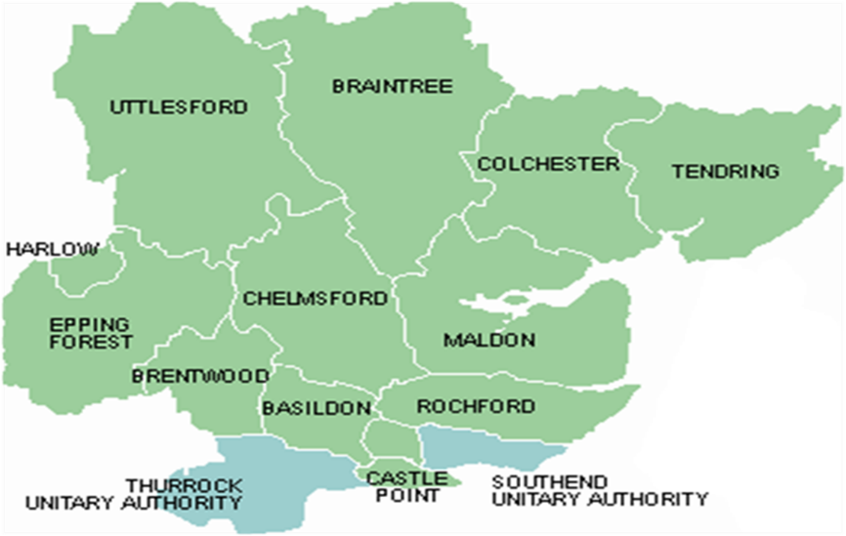
By the end of 2025 their will be between 14 & 28 termly meetings, some of this will be based on the success of our secondary school work and their engagement in our participation work.

Impact
Over the years we have built the multi-schools council from 4 local schools and 1 key ambassador to over 440 schools and 100 ambassadors. We have ensured at each stage of our development that young people are at the heart of our direction and decisions and this will not change. However, to ensure we are capturing the real meaning behind our work we must develop better systems in the way we record and analyse our impact to ensure the sustainability of this model and have the best possible chance of taking it into other local authorities.

Core aims:
- Design and use feedback forms at all our educational sessions, gathering feedback from both staff and CYP, focusing on how knowledge has been improved.
- Develop the good practice seekers project in-line with the development of our new school’s awards system, linked to Bronze, Silver and Gold inclusive practice, while working within existing programmes such as the Essex ordinary available offer and the Essex SEND strategy.
- Establish a strong quality assurance system across every aspect of our work.
- Move away from ‘most engaged’ schools and look at what this engagement means, linked to our new school awards system.
As of September 1^{st,} 2023, we will have published our school criteria framework for our school awards system, learning from existing practice. This must align with existing pieces of work within education such as the ordinary available offer, our good practice seekers framework and the Essex SEND strategy.

Links to local and national guidance
The National Youth Work Curriculum (2020) - https://s3.eu-west-1.amazonaws.com/assets.nya2.joltrouter.net/wp-content/uploads/20210414232918/5.3.1-0923-NYA-Youth-Work-Curriculum-DIGITAL1.pdf
Review our quality assurance process within the wider youth service, how this applies to our work and links in with the NYA curriculum – Links to page 29

My life, my rights, Essex local area SEND strategy (2022 – 2027) - https://schools.essex.gov.uk/pupils/SEND/Documents/9456%20SEND%20Strategy%202022-27%20ACCESSIBLE.pdf
Measure the impact of voices and choices through local strategies – Links to page 18
CYP’s impact on education and training for professionals – Links to page 20

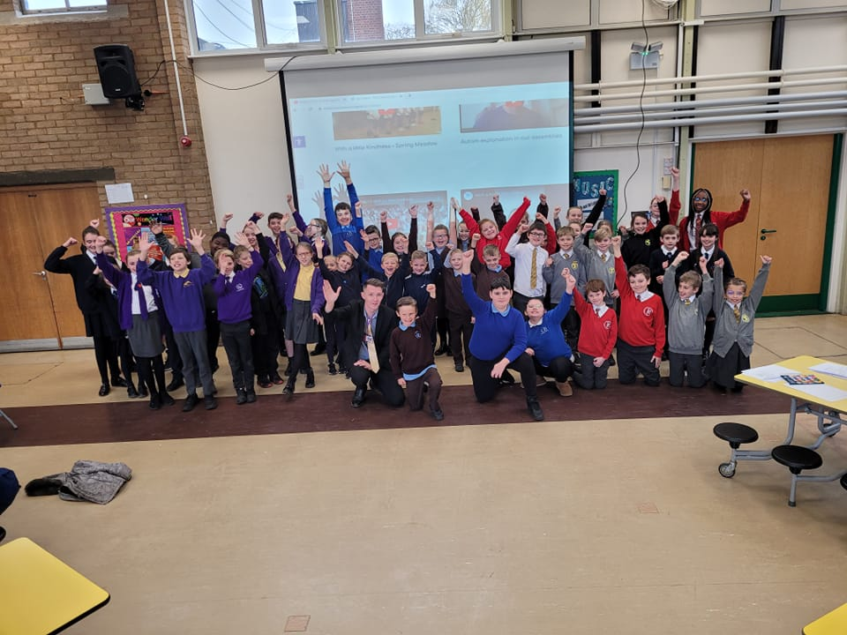

Secondary schools
Over the past 3-years we have made dramatic strides in the number of schools and young people we are engaging with but when analysing our work throughout this period we can see that it has been very primary school heavy. CYP don’t stop having SEND by the time they reach secondary schools, and we need to look at how we deliver our offer within these schools to ensure they are as committed as their primary partners.

Core aims:
- SEND awareness will remain central with the team looking at each session and how this may need to be differentiated for secondary schools.
- Develop videos aimed at engaging secondary schools more effectively in our model.
- Publish leaflets that include key information about our offer that can sit within all secondary schools who are part of our network.
- Gather feedback on why secondary schools may be finding it harder to engage.
- Ensure we are making regular phone calls to secondary schools to ensure they are aware of our offer.
- Consider how we can use ‘block bookings’ aimed at spending a structured period (up to 1-week) within the same school, having a flexible package that meets individual need.
- Utilize our website more effectively to help engage secondary schools that links into a learning hub model.
- Establish a structured way of working with our ambassadors in secondary schools that raises the visibility of our work.
- Introduce termly staff meetings with secondary school staff to ensure they are aware of our work but look at how this will also be used as mechanism to gather feedback.
- Understand and promote other areas of the Essex youth service (where appropriate).
- Work with partners within the youth service to explore how we can achieve a sustainable reach within the Youth Service and ensure teams across education, health and social care can inform schools of our work.

Ambassadors
Our ambassadors must underpin and drive forward every element of our success and positive promotion of SEND. The increase in ambassadors represents a growing reach and willingness to engage with us to ensure more young people are represented. We will continue to work hard to ensure this vital element of our work is never, ever a tick box exercise and that each young person brings a uniqueness to our group. Ultimately what links our ambassadors to how we work is the strong relationships that we build with them – ‘this is a team not an initiative.’
It is important to establish that no matter how big the multi-school council becomes in terms of it’s reach, the relationships will not be lost at any level.

Links to local and national guidance
The National Youth Work Curriculum (2020) - https://s3.eu-west-1.amazonaws.com/assets.nya2.joltrouter.net/wp-content/uploads/20210414232918/5.3.1-0923-NYA-Youth-Work-Curriculum-DIGITAL1.pdf
Young people feel confident to make decisions that will affect their own lives – Links to page 9
Youth work is for all young people – Links to page 9
We want our ambassadors to become leaders within their local communities – Links to page 9
When working with our ambassadors we will adopt trusting and safe relationships – Links to page 10
Our model is based on voluntary participation from our ambassadors, and this must always be respected – Links to page 11
Our ambassadors will support leadership and engagement with young people in the local area – Links to page 20
Young people need to understand and have a role in the sustainability of their environment – Links to page 24
We will support the ambassadors to develop skills within their roles – Links to page 25
The children and families act (2014) - https://s3.eu-west-1.amazonaws.com/assets.nya2.joltrouter.net/wp-content/uploads/20210414232918/5.3.1-0923-NYA-Youth-Work-Curriculum-DIGITAL1.pdf
Young people with SEND need to participate fully in decisions that have an impact on themselves and their peers – Links to point 19, B
The local authority must consult with children and young people – Links to point 27, (3), A

My life, my rights, Essex local area SEND strategy (2022 – 2027) - https://schools.essex.gov.uk/pupils/SEND/Documents/9456%20SEND%20Strategy%202022-27%20ACCESSIBLE.pdf
The Multi-School council ambassadors are embedded throughout the Essex 5-year plan – Links explicitly to pages 8, 14, 25, 30 and 37
Not all communities are inclusive, and our ambassadors have a role in helping to change this – Links to page 48
Joint commissioning arrangements must be in place to understand the needs of CYP – Links to page 51

The United Nations Convention on the Rights of the Child (1990) - https://www.unicef.org.uk/wp-content/uploads/2010/05/UNCRC_united_nations_convention_on_the_rights_of_the_child.pdf
There should be no discrimination of children and young people – Links to article 2
Every child has a right to express their views – Links to article 12
The child should have the right to expression – Links to article 13
Every child has the right to meet with other children – Links to article 15
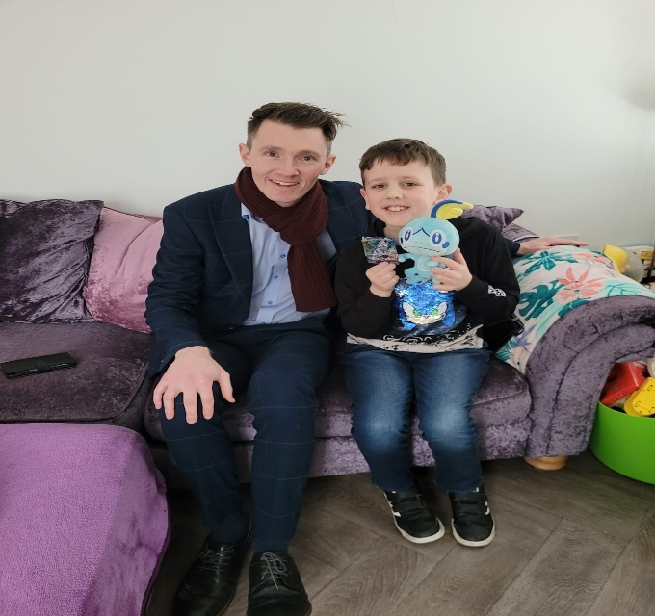

Core aims:
- Introduce termly ‘get together’ meetings that involve families but have a strong focus on relationship building with our ambassadors.
- Produce a local press release highlighting the impact of our ambassadors throughout this period.
- Explore why some ambassadors may not be as engaged and look at solutions to overcome potential barriers.
- Visit ambassadors within their school settings.
- Conduct interviews with our ambassadors to help ensure their work is understood.
- Offer ambassadors the opportunity to develop an ‘intro’ assembly within their school to ensure other young people are aware of their role.
- Develop an optional ‘ambassador checklist’ to ensure the ambassadors have some direction and guidance on how best to utilise their roles.
- Look at learning opportunities developed via our long serving ambassadors and how this knowledge can be passed down.
- Produce a leaflet on how to become a MSC ambassador and what the role would include in-line with our ambassador checklist.
- Ensure all headteachers are aware of ambassadors within their schools and value them as playing a key role in understanding SEND needs within their schools and ensure teams across health, social care, and education share opportunities where appropriate.
- Establish an ambassador celebration event and how this may link in with our CIC funding.
- Produce a mechanism to audit the impact our ambassadors are having, with a particular focus on their schools (where applicable) and the person-centred approach that we offer.

Building for the future
Whilst this plan focuses on the development within Essex, the long-term vision for the MSC is to build our model into other local authorities. More detailed plans on how this will happen will be part of our long-terms plan that will be published in the summer, but we have identified the basic building blocks below.

Stage one – 2023 – 2024 – While measuring the impact through our development in Essex we will build on our relationships in health, education, and social care teams to expand into the surrounding local areas. We will look to have youth workers based within these areas, following the same model that we have started in this area and linking CYP voices into local area systems.
Stage two – 2024 – 2026 – Have an established model that works across the East of England. This will include schools, community groups, links to further youth service provision and ambassadors within each local area. Using our impact to shape a sustainable business case we will be approaching the department for education to joint fund our model and support local areas to keep this model in place.
Stage three – 2026 – 2027 – Once our first two stages are complete, we will look to work with department of education to extend this into a national model that puts CYP young people with SEND at the hear of our services across the country. The model will be based on local intelligence that feeds into a successful national participation arena that is well connected and supported at every level.
Further detail on the content of this delivery will be explained in our long-term plan.
Additional notes
At the beginning of our journey with the Essex Youth Service we have published a book (https://www.amazon.co.uk/Toolkit-Teachers-Autism-Mental-Health/dp/B0BP4D27Q9/ref=sr_1_4?crid=2J8D4PH41M26D&keywords=a+toolkit+for+teachers&qid=1678265667&sprefix=a+toolkit+for+teachers%2Caps%2C228&sr=8-4 ). Part of our journey throughout this plan will be to ensure our book reaches far and wide. Along the way we will also consider how we may be able to publish more books built on SEND understanding. We should also consider how to capture the model of the MSC in a book and how it’s influencing a whole system.
As our ambassadors grow, several of them have now been involved over several years. Within the Essex youth service, we believe there will be opportunities to create pathways into employment. Part of this plan is to ensure our ambassadors have the skills and confidence to achieve and we will continue working with other partners within the local authority to ensure opportunities area realised across education, health, and social care too.
On publication of this plan the government have also published the long-awaited response to the SEND improvement green paper consultation (2022). SEND review, right support, right place, right time outlines various suggestions on what should change but possibly lacks clarity on how this will happen. However, the plan does highlight the need to engage with critical partners, including CYP and in following up our response to the consultation we will be looking to engage with the government through our ambassador network. By the time we come to publishing our long-term plan in the summer we hope to have gained further clarity on these plans and include links to our vision moving forwards.
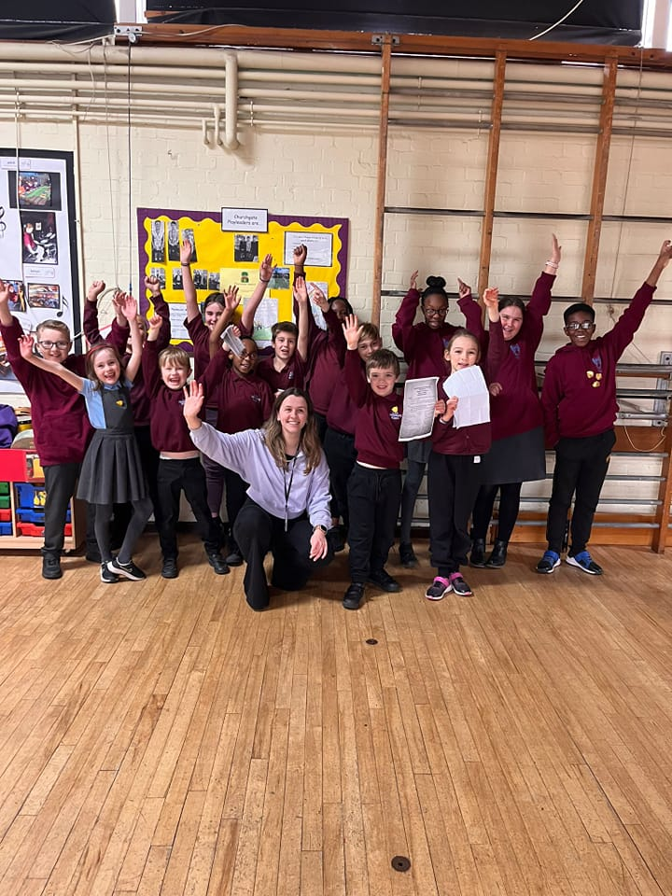

Conclusion
What a journey it has been so far. We are proud of where we have taken the MSC from but at the same time we know there is a lot more to do. SEND awareness within schools, within our communities and within lives can still be limited – we must change this. We are thankful to the Essex local authority, the Essex youth service and the Essex Integrated Care Boards that are funding and supporting our work – without their support we would find it very challenging to make any forward progress.
‘Promote positive perceptions towards young people with special educational needs and mental health challenges’ – 2023

Published April 2023,
Kierran Pearce, Multi-Schools Council Lead
Sarah Templeman, Multi-Schools Council Team leader
Amy Gair, Multi-Schools Council Team leader

