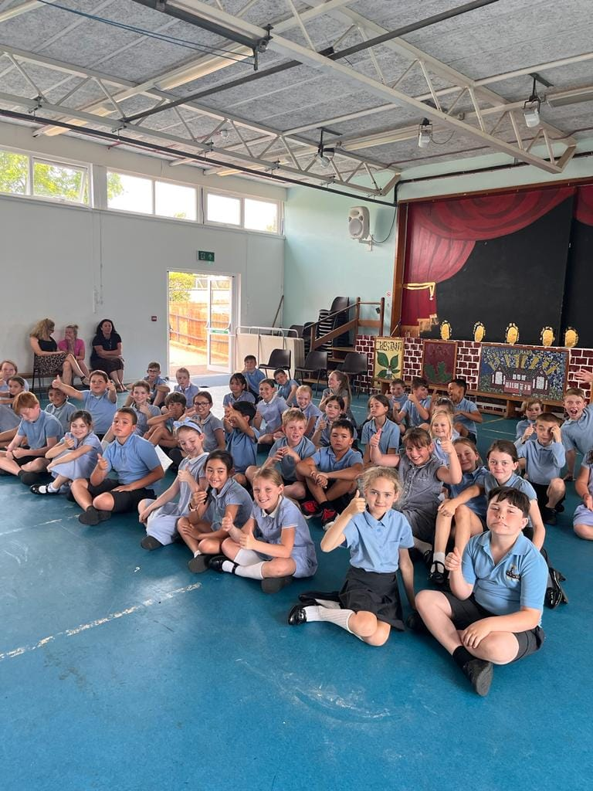

The Multi-Schools Council 2023

Behaviour in schools report

Introduction

Following on from last summer’s school attendance report the group wanted to discuss the impact of young people’s behavior in schools across Essex. To put this report together the multi-school’s council (MSC) team spoke with just over 300 young people both in primary & secondary schools, including a high majority with special educational needs (75%).
The group wanted to explore the current feedback from young people gaining their feedback on what contributed to both positive and poor behavior in schools. As part of our awareness raising, the MSC advocates for every behavior to be seen as a form of communication and so to understand where some of this behavior may come from, the report will be useful in our own perception changing work. We also believe the views of young people could help influence different approaches and policies within schools and academies.
This short report includes detail on:
- The environment and ‘safe spaces’
- Sensory needs
- A strong rewards system
- Strong boundaries & consequences
- Vaping
- Break & lunch times
- Substitute teachers
- Time out
- One to one learning
- Peer to peer support
- Speaking with adults
- Summary
The report will break down the key themes highlighted by young people. The young people we spoke to would like to the report to be used alongside our 2022 school attendance report as a way of supporting those that may be finding school difficult.
The environment and ‘safe spaces’
Time and time again we hear from a range of CYP that the environment plays a key part in how they engage within an activity and especially from those who may have a learning difference. To start with a consideration to be looked at within your own school is when was the last time we conducted an accessibility inspection? Sometimes when we hear about accessibility inspections, we can be drawn towards thinking of physical differences but some of the feedback gets us to think about all areas of need.
As well as making a whole area accessible there was a lot of talk about individual spaces and the benefits, they can have for CYP. We will come back to the term ‘safe spaces’ in a moment but these spaces had a number of names; Calm zones, corners, rainbow rooms, the cave, positive spaces, sensory rooms, peace spaces, bubble rooms. Whatever the name there was an emphasis from young people on feeling safe. The term safe spaces are something we have consistently used in our own work but after recent comments we have really reflected on this term because it was made clear to us that every space in a school should be safe. What we need to establish here is the difference between spaces within the environment that can add extra value to a young person & the feeling of safety but applying safety across our entire school environment through channels such as an accessibility inspection. We must also continue to reflect on the importance of Maslow’s hierarchy of needs and how these feed into our learning expectations for young people.
Fitting under this area too was the conversation around better use of outside spaces. As highlighted in a few MSC reports CYP are consistently talking about the positive effects of outside learning opportunities and the positive impact on mental health. So, another key consideration here is how much do we utilize our outside spaces? Approaches within schools that enhance the environment were mentioned several times, mainly from CYP within secondary education. The most common approach mentioned was THRIVE but we know there are a number of way’s of working that can create a positive learning environment.
The final element of this section was a focus on increasing the use of technology within all our environments. We have seen a pattern in these responses since Covid and our subsequent report about the transition back into schools. We also picked up comments last year regarding our school attendance report. In relation to this report CYP felt that more investment was needed in better technology within schools that would enhance their learning experiences and better prepare them for the future. We also heard about how better technology can help prepare young people for different environments and that preparation can be key for lots of young people to reduce anxiety before even coming in.

Sensory needs
An area that is very hot on our MSC agenda of building understanding, with many of our ambassadors adding this to our long-term vision of awareness. Understanding specific sensory needs is also seen as important to understanding why and how certain environments can better support young people. We will be responding to this internally to look at how we could develop a more specific sensory needs awareness session.
Coming back to the comments collected the first area focused again on specific spaces. In several meetings, it was suggested by CYP that sensory rooms should be compulsory in every school. We appreciate that there are limitations on spaces & funding but if you haven’t got a sensory room and these limitations are not a problem – Could you consider it? Some mentioned how having a sensory space within the school made such an impact that it could ‘Turn a bad day upside down’.
Moving on from specific spaces CYP spoke about the importance of fidget toys and resources to support needs. There were many conversations about how in some circumstances fidget toys had been banned or taken away. From another perspective we know there can at times be challenges in managing expectations on why these types of resources are needed to support sensory needs and when misused or mismanaged it can have a negative effect on a learning environment. However, young people within these meetings explained how this could be overcome by explaining why some people need resources like this – not as an extra opportunity to play but to ensure they can access the learning. With some extra explanation from adults (or young ambassadors!) these challenges could be overcome. So, from a positive perspective many young people said these fidget toys are vital to ensuring their sensory needs are met within the school environment which we have already discussed. In addition, having access to ear defenders was another hot topic and one CYP felt very strongly about. Like the importance of having a sensory room CYP felt every school should make ear defenders available as a norm.
Finally, the groups spoke about breathing. Too often in the past ‘breathing’ may have been associated to times of heightened emotions. Although many feel we have moved on from days of ‘I can see your angry so just breath and count to 5’ they feel the whole practice of taking time to just stop and breath should be used more within a school day. Breathing exercises here were associated with support some sensory needs and should be considered.

A strong rewards system
We all like a reward from time to time? Underpinning positive behavior in schools was CYP’s views on making a positive reward system work well. For this section we are going to break down the different suggestions, hopefully giving you some food for thought (there is a link to food below, see if you can find it!):
Class + Individual points – The clear message was there should be a mixture. If we only focus on one of these we are not maybe being as inclusive as we could be, was the general feedback.
Letting my parents know – We heard about many ways this could be done from postcards to online messages but that more time and care could be put into this as it would promote positive behavior.
Rewards assemblies – The majority of CYP advocated for these sighting that they had a positive impact. These assemblies included approaches such as star of the week but that it was also important to acknowledge individual needs should be considered.
Collecting stamps – Another popular suggestion was around collecting something visual (more below) that can form some port of a personal passport. It was suggested that this could be linked into a further reward system where you ended up receiving something such as a badge or a marble.
House points – From both primary and secondary schools CYP spoke about how if correctly done a strong house system really could promote positive behavior. This helped give some young people a team feel and a collective – ‘we are working towards something’.
Exclusive perks – This one was more from secondary aged CYP around getting specific things that made their days easier. The most popular suggestion here by a long way was jumping the lunch que!
Movie afternoons – They speak for themselves!
Headteacher awards – Very popular across all age groups once again. They felt this recognition really meant something to them and in some schools, we heard about how this is working well.
Recognition boards – Something more visual that celebrates achievements and if done correctly can promote positive role models that CYP can aspire too.
Trips – Another suggestion that came more from our secondary aged cohorts but one that many felt could make a big difference to promoting positive behavior. CYP are still reporting that this has dipped considerably since Covid-19.
The key question for this section is: How many positive reward systems from this list have we tried or are we using?

Strong boundaries & consequences
This area of the report also meant a lot to the CYP involved. Many of them were keen to get across that although these reports are from CYP they are not just based on making things ‘soft & fluffy’ and understand the need for strong boundaries & consequences. Going even further, many of the CYP we spoke with agreed that without strong boundaries & consequences behavior certainly got worse.
What this section hopes to reflect upon is how to do this in a way that is relatable and clear for young people. Building on this they have asked for consequences to have a logical link to the action. Just having a blanket consequence system many felt because how we respond to something is individual & any system that is dealing with a certain level of behavior should reflect this. CYP were clear that behavior consequences & boundaries within our school gates should be a separate issue to challenges with school attendance. Some CYP we spoke with felt very frustrated that approaches to behavior were also being applied when CYP were not in school and then when they were coming in this made the whole experience difficult (please refer to further guidance on school attendance).
Clear rules help us. If CYP understood the rules or they were explained in a way that was clear this really helped them to accept the boundaries. One approach CYP felt was very outdated was the idea of detentions. This links in with the idea of having more logical consequences that links to choices made. Many felt that detentions don’t really teach us anything. A better approach may be things such as supporting the community, giving back time in a more positive way if indeed this has a link to action. In addition to the rules where schools have strong values, that are made clear and repeated to CYP regularly, many felt this helped set the boundaries clearly.
Another approach CYP felt didn’t work was having names written on a board. Not only did this then make it very difficult for the young person to move on and improve many felt it could also feed negatively into the attention that was trying to be gained for whatever reason. Several schools spoke about their crackdown on bullying which was wholly supported by the CYP we spoke too. Where CYP wanted to see stronger consequences was about bullying and ensuring they were working hard to ensure this behavior can be improved.
A strong behavior policy is what should underpin all of this according to CYP. Where young people are given a voice in the design of this policy, they said it was more relatable and again better understood/accepted by young people. In addition, CYP felt that in collaborating towards a better behavior policy and listening to CYP this shouldn’t just include ‘the school council’ – for a policy to work in practice young people felt you needed a range of CYP involved (including ages). Finally for this section, CYP still felt there was too much ‘negativity’ when it comes to talking about ‘behavior’ and that boundaries & consequences should be spoken about positively in a way that is going to help the young person because that’s what we are all striving for.
The key question here is are your CYP involved in the production/updating of your behavior policy?

Vaping
An area that possibly we didn’t expect to be writing about before producing this report but a topic that came up regularly within our secondary aged engagement. The consensus was that vaping was on the rise and contributing towards negative behavior amongst CYP.
One general suggestion was that SLT teams in schools need to be more present around the school, especially in hot spots such as toilet areas where the problem was growing. CYP were keen for schools to push for vape detectors within their toilets to help tackle the growing issue. Other suggestions included having more awareness about vaping within our education system as they felt this was lost and having outside groups come in and talk about its dangers.
The reason CYP felt this linked into school behavior was the pressure being placed on peers to join in. Like other trends, things like this can take off very quickly according to young people and that the issue needed to be tackled now. They were also worried about the impact on health needs of young people and how this may affect behavior in schools moving forwards.

Break & lunch times
Many CYP we spoke to felt that these times were particularly difficult and explained them as ‘hot spots’ when it comes to discussing behavior. We are going to break this down below into the most common themes that came up:
Clubs that focus on positivity – An opportunity to reflect on what is positive – this can be done in different ways through reflection on their school day’s or in general about their own personal lives.
Staying behind to complete work at break & lunch – There were mixed opinions on this. Some felt that this didn’t work for everyone because some of those who ended up staying in really did need that break space to be in the best place to learn. Others felt that it helped keep behavior positive on the playground and that it was something young people then wanted to work towards.
Stagger break/lunch times – Interestingly we wrote about this in our CYP Covid-19 report which you can still access via our website. Young people spoke about the positives of reducing the numbers within our playground by staggering break & lunch times (this was particularly true for CYP with SEND). They would like schools to consider if this approach could still be used?
More breaks – This speaks for itself. More context was added via our secondary aged groups who asked if schools consider data such as the average attention span of young people. Could we use information like this to really look at the structure of our days?
Better systems – The point here was that a general behavior system for when CYP are inside may not be appropriate when outside and that we could consider having a different policy for this space.
Football – A hot topic but one that CYP were very honest about. The overriding feeling amongst the young people we spoke to was that often football can cause more challenges than positives during break & lunch times and that these challenges often spill over into the classroom. The suggestion was that football during these times needed to be better managed with some clear rules & boundaries because unfortunately free play within this game often doesn’t work. This point came predominantly from our primary aged cohorts.
More opportunities & clubs – Linking back to our opening section about environments, many CYP spoke about how break & lunch times were just too overwhelming. Where there was an understanding amongst young people that adults will also need breaks, they felt that more clubs and opportunities, in smaller controlled spaces will allow for many more CYP to feel comfortable and safe.
Play leaders – How many of you have play leaders? Linking into the fact that adults will need a break at times too brings us too looking at CYP responsibilities and play leaders were suggested das being a positive by many of our CYP groups.
Play equipment – More investment into updated play equipment. CYP were asking if there are funds out there or could schools use fundraising opportunities to ensure they get more play equipment within their schools that would help to engage a wider range of CYP.

The halfway point…….but keep reading! Below is an overview of the key questions so far:
- When was the last time you conducted an accessibility assessment?
- How much do we utilize our outdoor learning spaces?
- Could you have a sensory room in your school?
- How many positive reward systems do you have in place?
- Are your young people involved in writing/reviewing the schools behavior policy?
- Could you stagger break/lunch times?
- Do we use data on attention spans to inform the structure of our school days?
- Have you got play leaders in your schools?

Substitute teachers
An issue that was raised predominantly by our secondary school cohort was the use of substitute teachers. The overriding feeling was that when substitute teachers were used behavior incidents increased. It would be interesting to see if the data from schools backed this feeling up?
In terms of responding to this issue CYP felt sub teachers needed better training. They felt there needed to be a focus on skills for teachers gaining and keeping the attention of classes but also some awareness about how to manage challenging behavior. CYP were using words like they felt ‘sorry’ for substitute teachers coming into positions where they didn’t know anything about the young people in the class and so were unable to spark any relationships. CYP were asking for teachers to be better prepared for covering classes and to use creative ways of passing on information so that relationships could be built quickly. In terms of better preparation, they also wanted schools to ensure sub teachers had the suitable subject knowledge to take on that lesson.
Again, underpinning all of this was the need for teachers to be sighted on the school’s behavior policy. Many felt that most sub teachers they had received over the years did not have enough awareness of school policy which meant when it came to managing challenging moments the staff seemed very unsure on what to do. Although substitute teachers may be isolated in their use, the groups we spoke with were keen to stress how this can then have a knock on for the rest of the day or even weeks ahead during that same lesson because boundaries have then been stretched.

Time out…..have a break, grab a…..(other chocolate bars are available)
Within this section some of what is spoken about may have been covered slightly in different areas already but is relatable to this section also. As already mentioned, CYP of all ages were keen for schools to explore average concentration times of CYP and look at how this influences break times throughout the day, not just in a way we have ‘always done it’. As young people were keen to point out to us, childhood has changed dramatically over the years, and this needs to be reflected upon within the way we use our education system.
Outside learning heavily featured again in this section but not just from a learning perspective. They want to use outside spaces more because they feel it has such a positive effect on mental wellbeing and they are using this space in the right way can help get young people back into the right places to learn. Even simple strategies like allowing young people to have a short walk, just to get that movement. At this point we are adding part of a short case study we produced back in 2021 that looked at the transition of a young person with a diagnosis of ADHD because some of that learning is relevant to what we are hearing here:
‘I used to attend a special school for much of my primary education which followed a very similar structure to what people call ‘mainstream primary schools.’ I spent most of my day in the same classroom, with the same teachers and with the same friends. I would move quite quickly from task to task and lesson to lesson which at times was way too much for me, but I couldn’t really say this. I started to get silly, shout out and do things that would distract other people in the class. When I reached the end of year 6 me and my family decided that I would give mainstream secondary a go. One of the big differences since settling into my new mainstream school is the fact that between lessons, I get the chance just to ‘walk’. I feel like this is enough for me to release some of that energy that would often get too much within my old class and I have that outlet of just being able to take a walk.’
We again understand that in both primary & secondary settings boundaries and decisions around systems such as time out cards need to be heavily considered but should be looked at on an individual basis, especially when this is about meeting SEND needs (although we would stress this doesn’t just apply to SEND needs.) Young people were also keen to have specific times within school day’s that were allocated for ‘reflection’. What we hear from young people is that historically ‘reflection’ has been used predominantly when recovering from something negative but that having time out to reflect on learning and positive progress can also be beneficial towards behavior in schools.
Movement breaks were another suggestion to help break up the school day. On this point young people were keen to use adults as an example saying how many of us to a short break when working, possibly to get up and make a cup of tea (I can hear some adults now saying, ah a chance would be nice) or even just to stretch and take ourselves a way from a screen. We know making sure we take breaks when we work is being much more recognized in the way we are better understanding our wellbeing and that we should also be applying this to young people in schools. Again, movement breaks may have historically been seen as an intervention for young people with SEND and while some of these young people will need more regular and intense interventions, basic movement breaks have benefits for all people!
On the back of this the promotion of breathing exercises was popular amongst young people. They felt just having the opportunity to take a moment and take in a few breathes was a helpful strategy for us to become more aware about ourselves. Young people were under no illusions that at first this type of intervention may seem ‘strange’ to some but that for our overall wellbeing we know taking time to stop and make a conscious effort to focus on our breathing is beneficial. Zones of regulation are something we have certainly seen a rise in over the last few years on our visits and again CYP were asking for more spaces within the class to be used as ‘zones’. Suggestions included how this may replicate different areas we see on things like public transport but allowing young people to enter a ‘zone’ that they feel they need at that specific point in the day to support their learning. Again, there was an acceptance amongst young people that this would need clear direction and boundaries, but could schools get creative?
Finally, there were groups of young people that suggested just having those 5-minute breaks allocated throughout a day helped manage expectations. There are obviously some examples of how those breaks could look within this section but there will be lots of examples online and through other sources. The key question for staff to consider was how often are breaks given throughout our school day within each year group?

One to one learning
We know staff resources can be more stretched than ever, but we still must include this within our report as it came up as positive intervention to supporting whole school behavior. As already explained at the start of this report CYP would like behavior to be explored and not labelled. Some young people felt that challenging behavior increased when work was either too hard or misunderstood and that this could be supported by more one to one learning opportunities.
The idea of zones was re-visited within this section, with young people asking for dedicated one to one learning zones within schools and possibly classrooms (again looking at some creativity around this). They felt that overall getting more one to one opportunities would help the overall learning experience of others in the classroom and not just those that end up getting that one-to-one support.

Peer to peer support
A common theme in many areas of our work and something we are always pushing for more of, based on what young people tell us. In relation to improving behavior in schools their thoughts are broken down below:
- Have wellbeing champions – So many reasons were listed in terms of what wellbeing champions will bring to your settings. Young people felt they gave responsibility to young people, built skills in young people for the future and helped create a positive image of mental health throughout the school – all this having a positive impact on behavior in schools.
- We listen to our friends more – No further comment needed.
- Class exchanges – Raised via our secondary school engagement but something they felt could benefit all ages. When things aren’t always going right class exchanges were seen to have a positive impact but should not only be considered when things aren’t going well but how we help develop social skills in CYP overall.
- Use compliments – In teaching we talk lots about positive praise but how often do we encourage this amongst peers? Looking at setting up systems to support peer to peer compliments should be considered according to our young people. We know from other areas of our work such as our self-esteem program that this needs to be encouraged more if we are serious about improving mental health in all our settings.
- Friendship benches – A primary heavy suggestion but again looking at the idea of using friendship benches around the school (not just outside!) to help young people get that peer-to-peer support that they say will help improve behavior in schools.
They key question here was how much peer-to-peer support do you encourage in your setting?

Speaking with adults
Although peer to peer support was more popular there was clearly a case for making sure specific focus time was still given on how we support both CYP & adults to come together and improve behavior in schools. Many CYP we spoke to were very positive about pastoral teams within their schools and all agreed they played a crucial role in supporting behavior in schools. In terms of improving those teams CYP felt that those teams needed to have easy access to ensure they were working – this was in relation to being flexible with when they can be seen although there was an understanding that capacity could be an issue. Many also felt that pastoral teams shouldn’t be seen as a ‘crisis team’ and should be more like a ‘listening ear’. This really resonated with our work across education and healthcare systems in that a young person should have to get to crisis point to get some level of support. One suggestion was to look at different tiers of support within a school and how actually that listening ear was important to ensure young people didn’t get to that crisis point, which then had an impact on their behavior.
There was lots of language about having ‘open conversations’ with staff. Young people wanted reassurance that they could have open chats with staff which many felt linked back to positive relationships. Young people suggested that at the start of academic years making sure young people were reminded through assemblies and chats in class that open conversations are positive and would encourage more people to speak out before issues impacted on behavior. Building on this young people felt it also had to be the ‘right adult’. We touched on this subject during our 2022 school attendance report about how young people will build relationships and connection with different staff members, just like adults will because it’s human nature. When they need that listening ear young people felt strongly that they shouldn’t be dictated to in terms of who they speak to but trusted to seek the adult they feel is most appropriate.
Something we heard more about from our primary cohort’s was ‘hot chocolate time’. Some schools used this as a reward at the end of the working week, others a small intervention to support behavior in schools. Young people felt the strategy didn’t have to be age specific and that it didn’t even have to be hot chocolate but just having a focus to a small group coming together could be more productive in terms of encouraging conversation. This links to our final point in this section again about just finding ‘time’. Making time to talk should be seen as priority not a luxury and if we really want to improve behavior in our school’s time must be given.

Summary
Just like our school attendance report last year we hope this report is seen positively and simply just portraying the thoughts & feelings of what young people across Essex are telling us. Behaviour was and is seen as a key priority from our conversations with young people and we feel it is about working together. We hope this short report can be used a starting point to explore this area in greater detail within your schools and create better opportunities to work in collaboration with your year groups. Throughout the 2023/2024 academic year we will be rolling out our brand new ‘Schools awards system’ which will also look at how CYP’s views are impacting the development of schools’ practice.
Final key questions to consider….
- What peer to peer strategies do you have in place?
- How do we use breaks throughout the school day, and does it link into attention times?
- How do we support substitute teachers and improve practice?

