Braintree MSC Meeting
John Ray Junior School
20th March 2024

Attendance
Terling Primary School
Sliver End
Felsted
John Ray

Apologies
Chatten Free
Beckers Green
Hatfield Peverel
White Notley
John Bunyan
Templars Academy
Great Bradfords
Rayne Primary School

Minutes
Great to see everyone this morning! Thank you to John Ray for hosting!

We asked young people their thoughts about inclusion and what it means to them. These were their responses:
Inclusion
- Including people who feel left out.
- Feel welcomed.
- Have a say.
- No outsiders
- Supportive
- Kindness
- It is ok to be different.
We asked what the good things and bad things about technology are, and there were certainly some interesting thoughts!
Technology
- Easier to call people.
- Easily hacked.
- Unhealthy
- No exercise
- Miss out on the fun
- Addictive
- Communication
- Knowledge
- Keep memories!
- Take your mind off things.
- Can easily be a fake person.
- Being mean
- Catfish

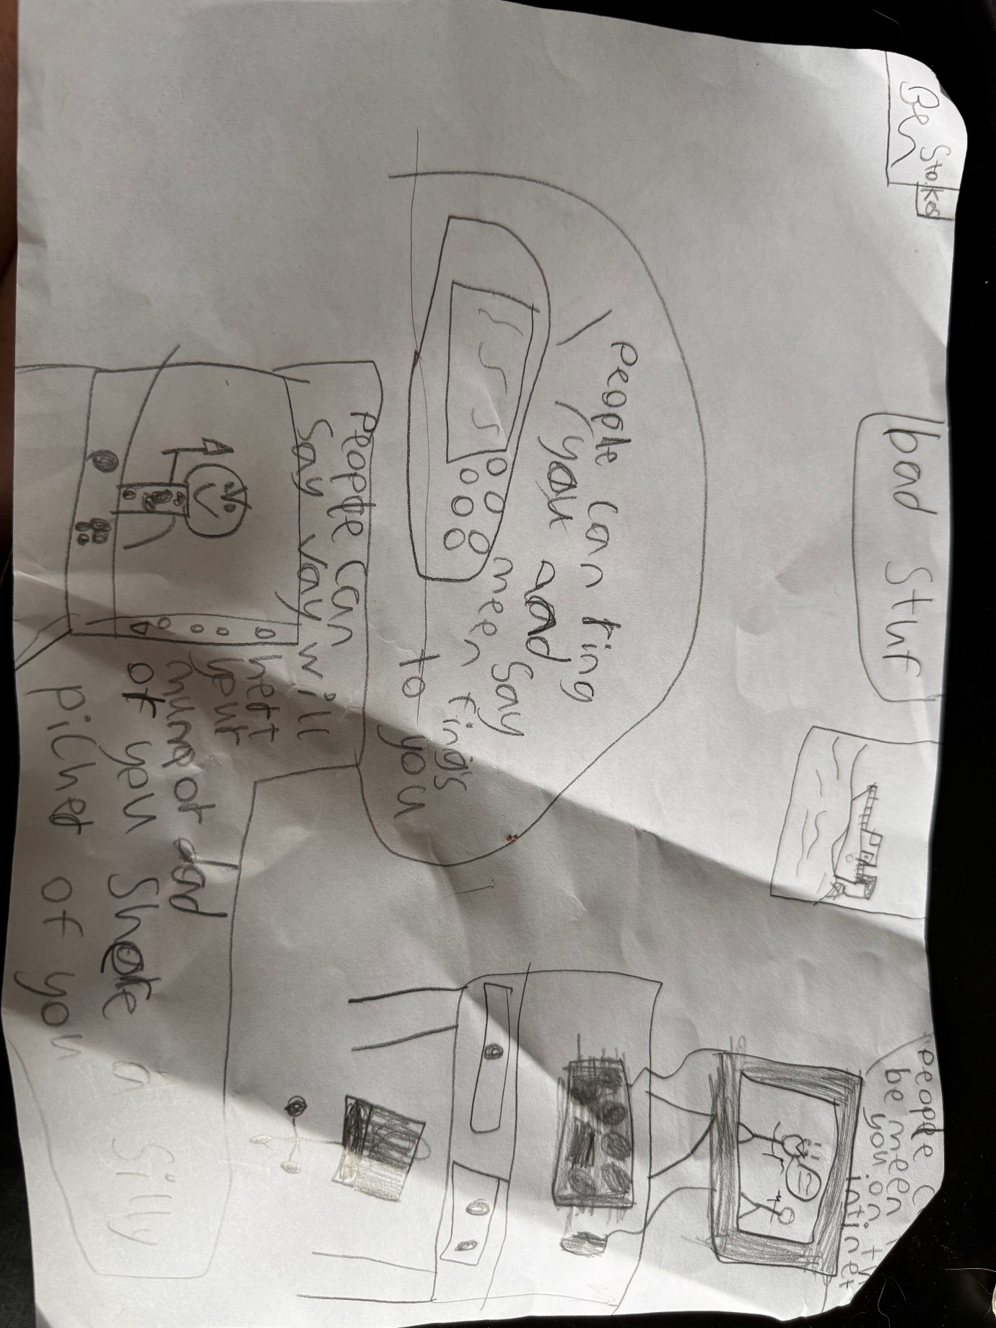

We asked young people how to encourage reading and how we can support people to be more involved in reading.
Reading
- Reading buddy
- Overlays
- Libraries
- Reading after lunch
- Reading area
- Quizzes
- Engaging books
- Relaxing
- Ask for help.
- Clubs
- Scrap levels of reading
- Comfort book

We asked young people on how they think happiness can be improved across the country.
Happiness
- Toys
- Helping their parents
- Friendships
- Being kind
- Pets
- Gaming
- Free drawing
- Variety of sports choices
- Friendship bench
- Developing playgrounds
- Golden time
- Brain breaks
- Pudding
- Daily movement
- Safe space
- School trips
- Morning exercise

The star of the week goes to Nicole from Felsted who contributed great thoughts and spoke confidently when adults asked questions. ALL of the young people did fantastically well in the meeting today!!

